여기서부터는 2007년 9월 학력 평가

1. 다음에서 글의 흐름으로 보아 어색한 문장은?
①People spend their vacation in different ways. ②Some enjoy going to the mountains to hike, ski, or just relax. ③Taking pictures is more exciting than drawing. ④Others prefer going to the beaches to enjoy the seashore activities. ⑤Still others like to relax by staying home and watching TV.
2. 다음 글에서 설명하는 자세로 알맞은 것은?
Today's Yoga
First sit up straight on the mat and bend your knees out to the sides. Next, place your feet together and put your feet to your body as close as possible. Hold your feet with your hands. Relax your body. Now breathe in and out slowly.

① | 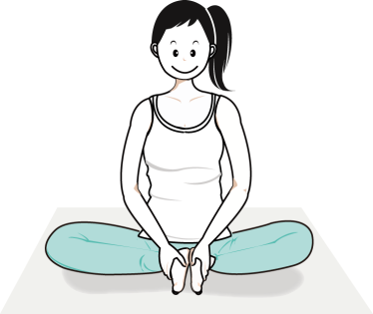 | ② | 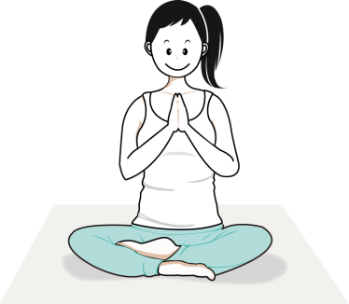
③ | 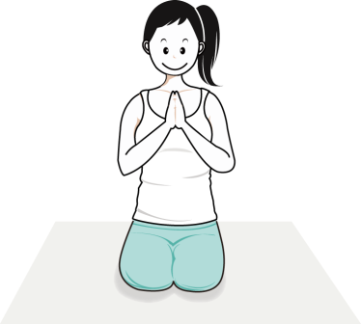 | ④ | 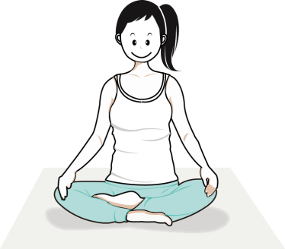
⑤ | 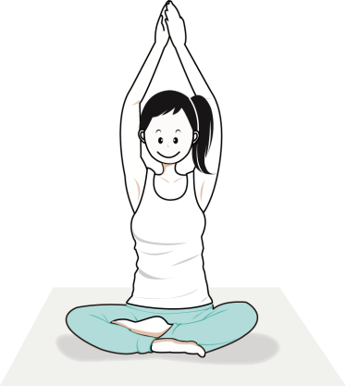
3. 빈 칸에 들어갈 말로 가장 알맞은 것은?
Do you have a piano at home? Its sounds are made when small hammers hit strings. The strings are inside the piano. On the outside of the piano, there are 52 white and 36 black keys. The white ones are long. The black ones, _______ , are shorter. They are also raised higher than the white ones.
* key : (피아노)건반
① at last② therefore
③ however④ for example
⑤ in addition
4. 다음 글의 중심 내용으로 알맞은 것은?
Some doctors tell sick people to take either warm or cold baths. Warm baths help the body relax and ease the pain. Cold water makes a person feel fresh. Cold baths are also used when the whole body has become too hot. They usually bring the body heat down quickly.
① 목욕의 효능② 목욕의 역사
③ 목욕과 미용④ 목욕과 위생
⑤ 목욕과 문화
5. 밑줄 친 'to turn over a new leaf'`의 의미로 알맞은`것은?
I've been pretty lazy. I make plans but I always delay things until it's too late. So I can't finish anything. If I keep on repeating this stupid cycle, I won't ever get anything done. So I've decided to turn over a new leaf. From now on, I'll do what I have to do right away.
*delay : 연기하다, 미루다
① 좋은 친구 사귀기
② 어려운 사람을 돕기
③ 날마다 계획 세우기
④ 약속 시간 늦지 않기
⑤ 마음을 고쳐먹고 새롭게 변화하기
6. 다음 글에서 얻을 수 있는 교훈으로 가장 알맞은 것은?
Minho had to write about an animal for homework. He searched the Internet, chose a report about monkeys and copied it. With a big smile, he gave it to his teacher. But Minho wasn't so lucky. His teacher recently read the same report on-line! Minho got zero points for his homework.
① 독서를 많이 하자.
② 숙제를 미루지 말자.
③ 동물 보호에 앞장서자.
④ 인터넷을 많이 이용하자.
⑤ 남의 것을 베끼지 말자.
7. 밑줄 친 부분에서 어법에 맞는 것을 골라 바르게 짝지은 것은?
When we are sick, we take some medicine to make us (A) feel / to feel better. But, how do we know that it is safe? If a new medicine is made, it is dangerous to give it to people (B)with / without knowing that it is safe. So the medicine is tested on small animals. It is (C)called/calling "animal testing".

(A) (B) (C)
① | feel | ……… | with | ……… | called
② | to feel | ……… | with | ……… | calling
③ | feel | ……… | without | ……… | called
④ | feel | ……… | with | ……… | calling
⑤ | to feel | ……… | without | ……… | calling

8. 밑줄 친'work'와 같은 의미로 쓰인 것은?
I got a cellular phone for my birthday from my dad. I'm so glad because it's the newest model. It's just what I wanted but there's a problem. It has some new functions and I don't know how they work.
*function : 기능
① He works so hard everyday.
② He usually works out in the gym.
③ The washing machine doesn't work.
④ It takes a lot of work to build the house.
⑤ The museum has many works of Picasso.
9 다음 글에 이어질 내용으로 가장 알맞은 것은?
Global warming, an increase in the Earth's temperature, has become a very serious problem.
Air pollution is one of the main causes of global warming. We have to do something before the problem gets worse. Scientists say that we can reduce the air pollution in many ways.
① 대기 오염의 원인
② 지구 온난화의 문제점
③ 인간으로 인해 생긴 재난
④ 대기 오염을 줄일 수 있는 방법
⑤ 대기 온도를 정확하게 측정하는 방법
10. 다음에서 글쓴이가 의도하는 것으로 가장 알맞은 것은?
I'm going to teach children how to spend money. It's very important to keep them from becoming a big spender. First, I will have them make their own pocket money. That will teach them money is not easy to get. And they will be more careful about spending it. I will also teach them when and where to spend money.
① 환전하는 방법을 가르치려고
② 은행 이용 방법을 알려주려고
③ 용돈기입장을 기록하게 하려고
④ 기부 문화의 중요성을 알려주려고
⑤ 돈을 현명하게 쓰는 방법을 가르치려고
11. 다음 글의 내용과 일치하지 않는 것은?
Eating in space is different from eating on the Earth. Some food is carried in closed bags. It is cooked and frozen before the astronaut carries it. All the water is removed from the food. In the spaceship, the astronaut puts the water back. He shoots hot or cold water into the food bag with a special gun. He eats the food through a small hole in the bag.
① 우주와 지구에서의 식사법은 다르다.
② 우주에서는 건조된 음식을 그대로 먹는다.
③ 어떤 음식은 밀폐된 봉지에 담아서 가져간다.
④ 음식을 냉동시켜 우주로 가져가기도 한다.
⑤ 음식의 수분을 제거하여 우주로 가져간다.

여기서부터 2005년 성취도평가
12. 다음 대화의 빈칸에 들어갈 알맞은 말을 고르시오.
A：Hello.
B：Hello. This is Julia. May I speak to Mr. Han?
A：I’m afraid he’s in class now. Would you like to leave a message?
B：Yes. Please tell him that I can’t go to school because ____________________. I have to go and see a doctor. My telephone number is 431-7553.
A：Okay, I’ll let him know.
B：Thank you very much.
① I’m sick today
② I like the doctor
③ I have to go to church
④ I am meeting my friend
⑤ I don’t want to go to school
13. 다음 대화를 읽고, 여자의 응답으로 가장 알맞은 표현을 고르시오.
A：Suh-won, you look healthier than you used to look.
B：Do I?
A：Yes. Do you exercise regularly?
B：Yes, I do. I jump rope one thousand times every evening.
A：Wow! that’s great. No wonder you look so healthy.
B：_______________________________________
① No thanks, that’s not enough.
② Let me see. It’s good.
③ I’m afraid you can’t.
④ Thank you for your praise.
⑤ Don’t worry. It’s not your fault.
14.다음을 대화를 읽고, 빈칸에 알맞은 표현으로 짝지어진 것을 고르시오.
A：What are you going to do when you finish school?
B：I’m going to be an announcer.
A：Sounds great! How are you going to achieve your dream?
B：First, I will try to imitate good announcers.
A：What else are you going to do?
B：Second, I will _______________ so that I will be well-informed. Third, I will ___________________ so that I can communicate with foreigners.
A：I’m sure you’ll be a great announcer in the future.
① get up early-go to the movies
② get up early-listen to the radio
③ drink juice-learn foreign languages
④ read lots of books-go to the movies
⑤ read lots of books-learn foreign languages

15. 다음을 읽고, 밑줄 친 단어의 뜻과 가장 가까운 단어를 고르시오.

The weather is not beautiful all of the time. Perhaps you can remember a day when bad weather made you afraid. One type of bad weather that scares many people is a thunderstorm.
① amuses ② frightens③ bothers
④ excites ⑤ pleases
16. 다음을 읽고, 글의 요지와 빈칸에 들어갈 말이 알맞게 연결된 것을 고르시오.
Nobody wants a life without love. So what should we do to avoid such a life? First of all, the effort must be made by ourselves. Rather than waiting for other people to provide the love we want, we must love others first. By opening our hearts to others, we can get the love we are looking for. And the more love we give, the more we will ____________.
① We have to love others. - receive
② We have to open our heart. - lose
③ We have to avoid a life without love. - lose
④ We have to wait until others love us. - receive
⑤ We have to be an example for others. - want
17. 다음을 읽고, 글쓴이가 화가 난 이유로 가장 알맞은 것을 고르시오.
I recently visited City Hall to attend a meeting at 9 in the morning. My husband Joe and I arrived at the lobby at 8:15. I looked for the women’s restroom. I asked one of the guards for the directions. He advised me that the restroom was closed until the building was opened to the public at 9. That meant I had to wait. I was angry with his answer. How could this be possible in a public building?
① 경비원이 친절하지 않아서
② 화장실이 깨끗하지 않아서
③ 경비원이 시청의 일반인 출입을 제한해서
④ 화장실을 오전 9시 이전에는 사용할 수 없어서
⑤ 시청의 휴게실이 청결하지 않아서
18. 다음 글의 분위기로 알맞은 것을 고르시오.
Mr. Kim is a famous announcer. Today, however, he is very nervous. He is going to meet two people, who will both be interviewed for the first time. One of them is a young movie star, and the other is a top Olympic sportsman. Neither of them has been on TV before. Both of them are nervous and neither of them is smiling.
① 쓸쓸하다 ② 긴장되다③ 편안하다
④ 적막하다 ⑤ 활기차다
19. 다음을 읽고, 내용과 일치하지 않은 것을 고르시오.
There are two types of germs. One is bacteria and the other is viruses. Germs are very small creatures and they cause most illnesses. Viruses can only live for a very short time outside of the living cells but they can spread easily once they are in your body. Bacteria are so small that you need a microscope to see them. There are bad bacteria like the ones that can cause food poisoning, as well as good bacteria like yeast.
*yeast: 효모(균)
① Most diseases result from germs.
② Viruses and bacteria are germs.
③ Viruses soon die outside of the living cells.
④ Bacteria are too tiny to see with the naked eye.
⑤ All bacteria are harmful to our health.

20.다음 지시문을 읽고, 무엇에 대한 사용방법인지 알맞은 것을 고르시오.
1.Place the cover carefully over the tip.
2.Push the on/off button to turn the unit on.
3.Place the sensor tip well under the tongue.
4.Don’t open your mouth for about 60 seconds.
5.When the peak temperature is reached, the unit will beep.
6.Read and record the temperature.
① 무선호출기 ② 전자체온계
③ 초음파탐지기④ 혈압측정기
⑤ 공기정화기

