중3 읽기 시험
2003 중 3 학력평가
1. 다음은 해파리(jellyfish)에 관한 설명이다. 글의 내 용과 일치하지 않는 것은?
A jellyfish doesn't have a heart, a brain or any real eyes, but can swim over 3,600 feet in a day. Jellyfish come in all shapes and sizes. Some are very small and live in lakes and streams. Others are over 100 feet long.
① 바다에서만 산다.
② 심장도 뇌도 없다.
③ 크기와 모양이 다양하다.
④ 길이가 100피트를 넘는 것도 있다.
⑤ 하루에 3,600피트 이상을 헤엄칠 수 있다.
2. 다음 글의 종류로 가장 적절한 것은?
Now you'll have to make an excuse if you're late. Say that you got up late, or that you had a bad headache. But, don't say it was because of Star Airlines. If so, no one will believe you anymore. We have the best on time service this year. Call Star Airlines at 82-2-7000-8282.
- 상문 ②일기문 ③전기문 ④보고서 ⑤광고문
3. 다음 글에서 ‘I’의 심정으로 가장 적절한 것은?
I always had a part in the class play, but I couldn't get the part I wanted. I wanted to be Peter Pan in the fall program. Instead I was Rock. I wished to be Rudolph in the Christmas play, but I was Rudolph's friend. When the spring musical was "Snow White", I really wished to be Prince. However, the teacher didn't give me the part of Prince. I was Tree No.3!
① 행복하다② 실망스럽다③ 자랑스럽다
④ 설레인다⑤ 만족스럽다
4. 다음 글의 빈칸에 가장 적절한 것은?
Mr. Guppy was a very large man. He was much bigger than most men. He couldn't find big clothes easily. His feet were too large for most shoes. He could not stand up straight in buses and trains, because the roofs were too low. Life was for Mr. Guppy.
① safe② exciting③ not bad
④ not easy⑤ wonderful
5. 밑줄 친 부분에서 어법에 맞는 표현을 골라 바르게 짝지은 것은?
Do you live in a place (A)why/when/where earthquakes happen? Earthquakes take place in many parts of the world. People can be hurt or killed during an earthquake. Even a whole city can (B)destroy/destroying/be destroyed.
(A) (B)
① why ・・・・・・・・・・・ destroy
② when・・・・・・・・・・・ destroying
③ when・・・・・・・・・・・be destroyed
④ where ・・・・・・・・・・・ destroying
⑤ where ・・・・・・・・・・・ be destroyed
6. 다음 글에서 주어진 문장이 들어갈 위치로 가장 적절한 곳은?
He was carrying heavy boxes by himself.
Last Saturday Paul moved to a new apartment. ( ① ) Then his friends came over and helped him to carry them. ( ② ) He said, "Thank you very much." ( ③ ) His friends said, "We're happy to help you, Paul. That's what friends are for." ( ④ ) He was happy to have such nice friends. ( ⑤ )
7. 다음 글의 빈칸에 가장 적절한 것은?
Can you name dangerous sports? Perhaps your answers are football, boxing, skiing, and so on. What about ping-pong? Not many people would say that ping-pong is dangerous. , according to a report in 1992, over 1,450 people had to go to hospital after they played ping-pong.
① At first② Therefore
③ However④ In addition
⑤ As a result
8. 다음은 서점 주인이 재치있게 대처하는 유머러스한 만화의 한 장면이다. 밑줄 친 부분 (A)에 가장 어울리는 것은?
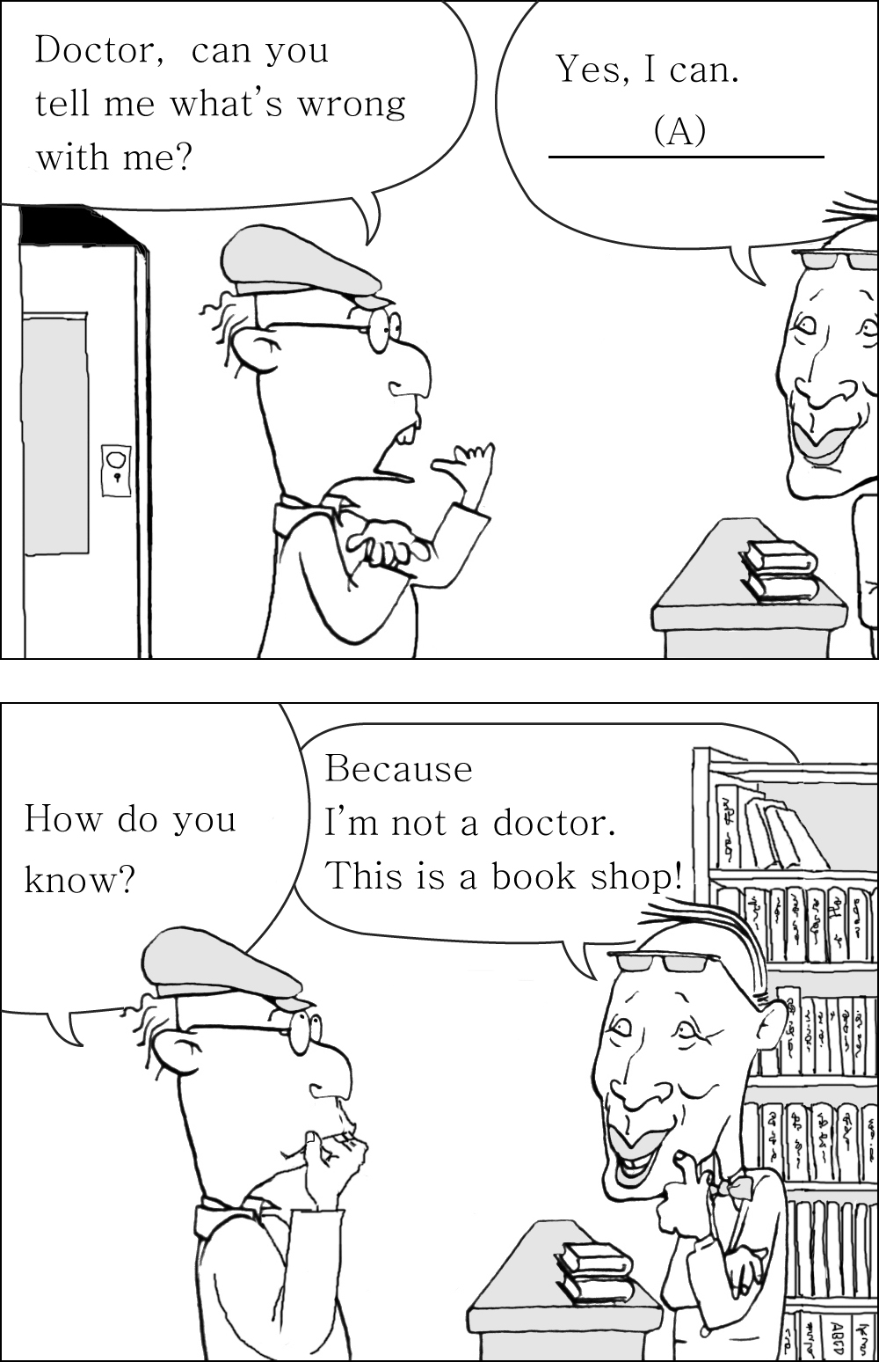
① I'm fine.② It's so cheap.
③ Nice to meet you.④ I broke my arm.
⑤ You need new glasses.
9. 주어진 글 다음에 이어질 문장의 순서로 가장 적절한 것은?
Long ago there was no money. There were no stores, either. People couldn't get the things they needed.
(A) That's how goods were traded.
(B) So, first they had to find someone who had the things they wanted.
(C) Then they had to give the person something he or she wanted.
① (A)-(C)-(B)② (B)-(A)-(C)
③ (B)-(C)-(A)④ (C)-(A)-(B)
⑤ (C)-(B)-(A)
10. 다음 글에 나타난 글쓴이의 의도로 적절한 것은?
You talked about staying in hotels, but I think camping would be better. There are a lot of nice campgrounds. They have showers and toilets. Some of them have swimming pools, too. Besides, camping is a lot cheaper than staying in hotels. We can cook our own food, so we won't have to spend money in restaurants. We can also meet many interesting people there. Wouldn't you like to try?
- 사 ②설득 ③허락 ④위로 ⑤사과
11. 다음 글의 제목으로 가장 적절한 것은?
Long ago people used many different ways to measure things. It was hard to talk about *length with people from different countries. About two hundred years ago, scientists in France invented a new system using a ‘meter’. Now the new system is used in almost all countries.
* length 길이
① 의학의 발달
② 발명의 고통
③ 미터법의 발명
④ 과학자의 특징
⑤ 프랑스의 역사
12. 다음 글에서 글쓴이가 주장하는 바로 가장 적절한 것은?
Many people are spending lots of time and money on their better looking. They follow after famous movie stars or singers. Of course, we need to make ourselves beautiful to enjoy our lives. The problem is that we are missing some important things. Good looking is not the most important thing. We should think of the beauty of the mind as well as of the body.
① 환경을 깨끗이 해야 한다. ② 최신 유행을 따라야 한다.
③ 건강은 젊어서 지켜야 한다. ④ 무리한 체중조절은 위험하다.
⑤ 내면의 아름다움도 중요하다.
13. 다음 글에서 설명하고 있는 직업을 나타낸 그림으로 가장 적절한 것은?
They have to work fast. Some of them connect the hoses and others put up the ladders. They run up the ladders with the hoses. They have to help people who are burned or hurt. They must know how to help people who are in smoke and fire.

① | 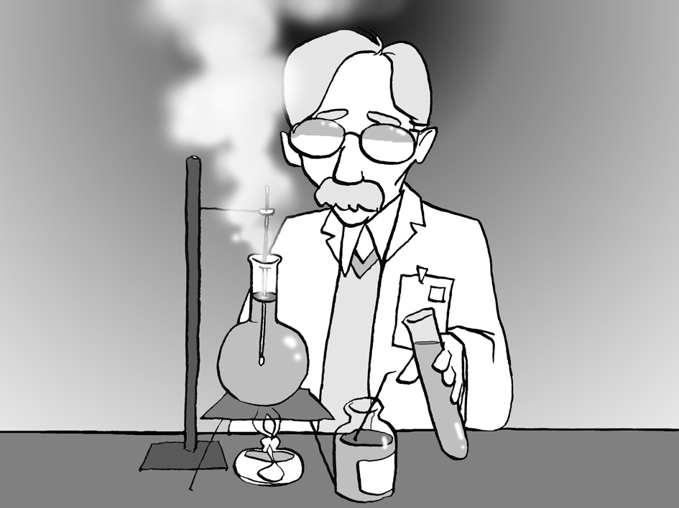 | ② | 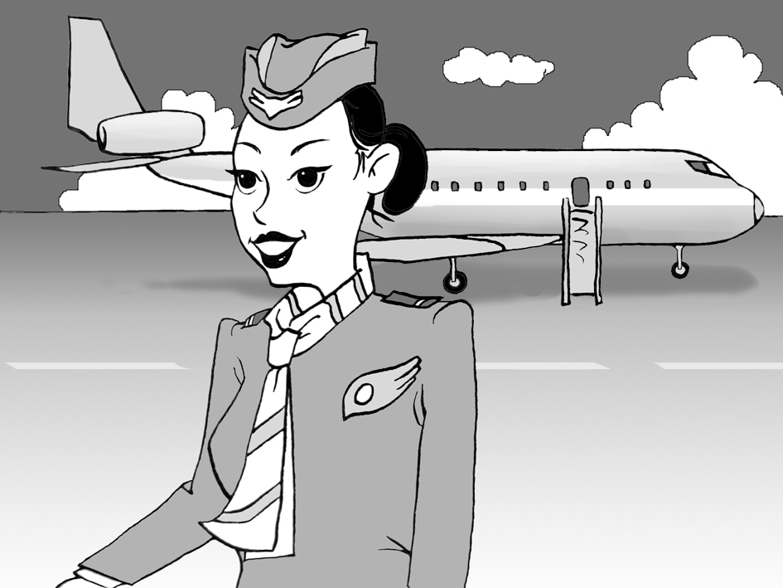
③ | 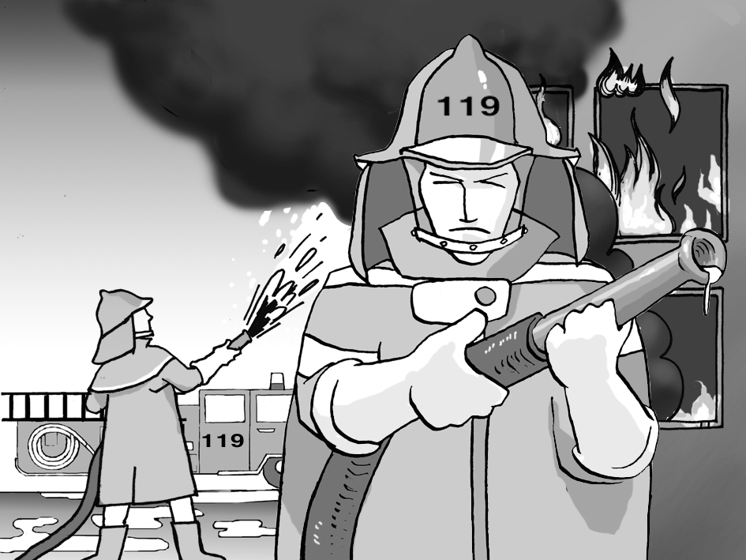 | ④ | 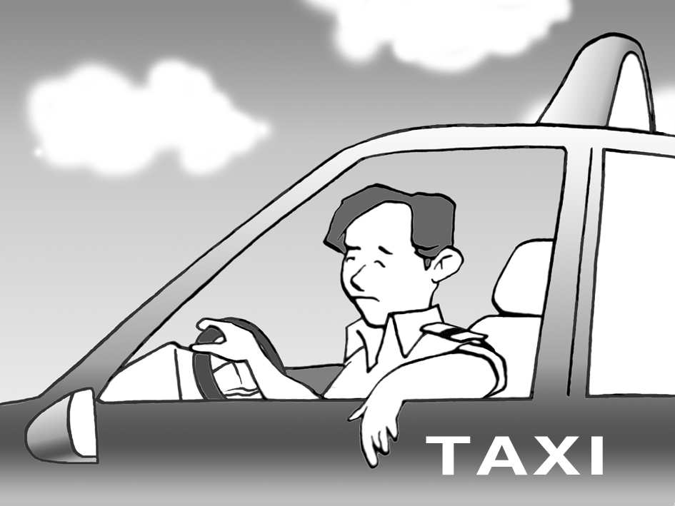
⑤ | 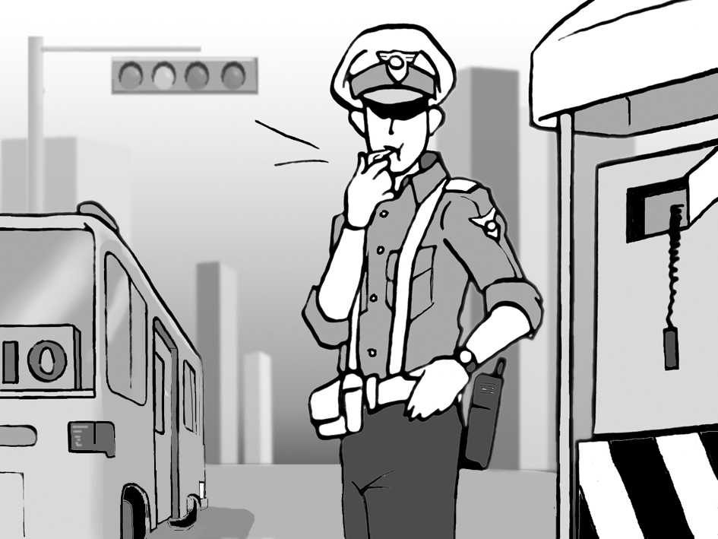
14. 다음 글에서 전체의 흐름과 관계가 없는 문장은?
Mother sea turtles make a nest in the sand to lay eggs. ①They dig the nest with their powerful arms. ②Once the nest is finished, they lay about 100 eggs into the nest. ③Many children like sea turtles. ④The eggs are about the size of ping-pong balls, and feel soft. ⑤Then the mother sea turtles cover the eggs and the nest with sand.
15. 다음은 인터뷰의 일부이다. 빈칸 (A)와 (B)에 들어갈 말을 <보기>에서 골라 짝지은 것으로 가장 적절한 것은?
Julia: (A)
Brad: I love science-fiction movies. One of my favorite movies is Terminator 2. I've seen it three times.
Julia: (B)
Brad: I like it because the story is exciting. All the actors are good. But I don't like the ending of the movie. It is so sad.

<보 기>
a. What kind of movies do you like?
b. Tell me what you like about the movie.
c. When did you first get interested in movies?
(A) (B)
① a・・・・・・・・・・・ b
② a・・・・・・・・・・・ c
③ b・・・・・・・・・・・ a
④ b・・・・・・・・・・・ c
⑤ c・・・・・・・・・・・ a
16. 다음 글의 빈칸 (A)와 (B)에 들어갈 말이 가장 바르게 짝지어진 것은?
Ali and Sami loved soda. Ali always drank half of his bottle and then stopped. Sami did the same. Then they looked at their bottles. Ali was always happy because his bottle was still half full. Sami was always sad because his bottle was already half empty. The two bottles were (A) , but Ali and Sami saw them (B) .
(A) (B)
① half full・・・・・・・・・・・・ happily
② the same ・・・・・・・・・・ happily
③ large size・・・・・・・・・・ differently
④ different・・・・・・・・・・・ the same
⑤ the same・・・・・・・・・・・ differently
여기서부터는 2007년 9월 학력 평가
17. 다음 글의 종류는?
Come and experience a fantastic world. You can see the deep blue ocean and beautiful beaches. We've been sharing the natural beauty and history of this island with travellers for over 50 years. You can enjoy true nature in comfort. Now we invite you to experience it with us.
① 일기 ② 광고문
③ 논설문④ 경고문
⑤ 신문사설
18. 글쓴이의 심경으로 가장 알맞은 것은?
On my school field day, our team was playing soccer against the purple team. All of our team was shouting, "Orange!" All of the purple team was shouting, "Purple!" By mistake, I screamed, "Purple!" Everyone on both teams looked at me. My face turned red.
① 편안하다.② 따분하다.
③ 유쾌하다.④ 자랑스럽다.
⑤ 당황스럽다.
19. 밑줄 친 'It'이 의미하는 것으로 알맞은 것은?
It is a big stream of electricity. It is not made by power plants. It happens in nature. It begins in a big storm cloud and travels very fast. It can start a fire on the ground. It can also burn down a house and split a tree. If it hits a person, it may kill him or her.
① storm② flood
③ thunder④ typhoon
⑤ lightning
20. 다음 글에 이어질 문장의 순서로 알맞은 것은?
Here's a recipe for mashed potatoes. Begin by peeling two large potatoes and boil them in a pot of water.
(A)Then take them from the pot and remove the water.
(B)Mix them with melted butter, salt and pepper and serve.
(C)Put them in a large mixing bowl and mash with a potato masher.
① (A) - (B) - (C) ② (A) - (C) - (B)
③ (B) - (A) - (C) ④ (B) - (C) - (A)
⑤ (C) - (A) - (B)

