**중학교 3학년**

**2003년 11월 학력평가(진단편가 (가)형)**

1. 대화를 듣고, 남자의 여동생을 고르시오. (2번)

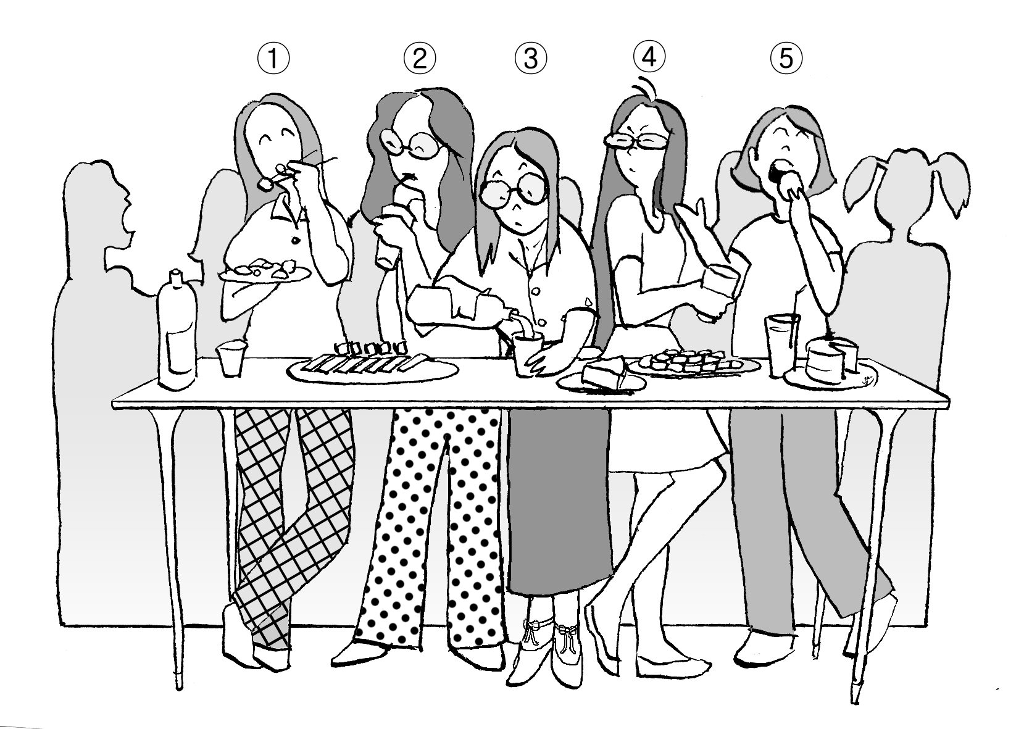

W: Is your sister at the party now?

M: Sure. Uh, she's there. Do you see the girls at the table?

W: Yes. I see some girls there.

M: My sister is the one with glasses.

W: You mean the one wearing a long skirt?

M: No, she is wearing pants.

2. 대화를 듣고, 대화가 이루어지고 있는 장소로 알맞은 것을 고르시오. (4번)

① bank ② park ③ bakery ④ post office ⑤ shoe store

W: Good afternoon. May I help you?

M: Yes, I want to send this box of books to New York.

W: By ship or by air?

M: How long will it take by air?

W: It will take six or seven days by air but two months by ship.

M: I want to send it by air.

W: OK. It'll cost 20 dollars.

3. 대화를 듣고, 여자가 사려고 결정한 것을 고르시오. (3번)

① dog ② cat ③ bird ④ rabbit ⑤ hamster

M: What can I do for you?

W: I'm looking for a pet for my son.

M: Well, we have a nice dog right now.

W: Oh..., we already have one.

M: Hmm, what about a bird? It's very popular and it can sing for him, too.

W: Oh, that sounds good. I'll take one.

4. 대화를 듣고, 두 사람의 관계로 가장 알맞은 것을 고르시오. (4번)

① 교사와 학생 ② 의사와 간호사 ③ 택시 기사와 손님

④ 병원 접수원과 환자 ⑤ 식당 종업원과 손님

W: Good morning. Dr. Parker's office. May I help you?

M: Yes. My name is Kevin Brown, and I'd like to make an appointment with the doctor.

W: What seems to be the problem?

M: I have a terrible sore throat.

W: Let me see..., can you come at 2:00 this afternoon?

M: Sure. That's fine.

5. 대화를 듣고, 남자가 여자에게 전화를 건 목적으로 알맞은 것을 고르시오. (1번)

① 함께 낚시 가려고 ② 약속을 취소하려고 ③ 집으로 초대하려고

④ 도서관에 함께 가려고 ⑤ 약속 시간을 바꾸려고

W: Hello.

M: Hi! It's me!

W: Oh, hi, Tom! How are you?

M: Fine. What are you doing this afternoon?

W:I'm not sure. I'll probably stay home. How about you?

M: Well, I'm planning to go fishing. Would you like to join me?

W: Sure. I like fishing.

M: Good! I'll pick you up at one o'clock.

W: OK. See you then.

6. 그림을 보고, 상황에 가장 알맞은 대화를 고르시오. (2번)

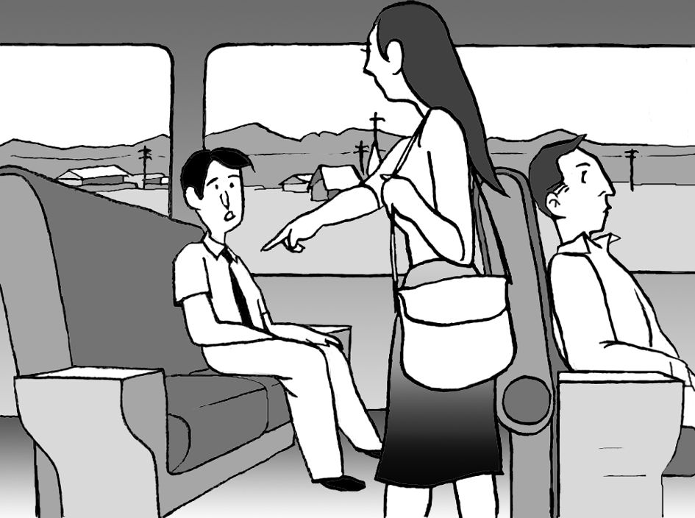

1. ② ③ ④ ⑤

① W: I'd like the menu, please.

M: Here you are, ma'am.

② W: Excuse me, is this seat taken?

M: No, it isn't. You can sit here.

③ W: Can I help you?

M: I'd like to exchange this bag.

④ W: Is there a parking lot near here?

M: Yes, over there.

⑤ W: Can I use your computer?

M: Sure.

7. 대화를 듣고, 남자의 마지막 말에 대한 여자의 응답으로 알맞은 것을 고르시오. (1번)

Woman :

① I'm an animal doctor.

② Yes, have a nice day.

③ Oh, that sounds very nice.

④ It's my pleasure to be here.

⑤ It's about two blocks from here.

M: Good evening, ladies and gentlemen. Welcome to our show. Tonight's winner will get a vacation ticket to Europe. Well, now here is our first guest.

How do you do, ma'am? Could you tell me your name, please?

W: Laura Jackson.

M: And what do you do, Laura?

8. 다음을 듣고, 내용과 일치하도록 빈칸에 가장 알맞은 말을 고르시오. (4번 – useful)

Elevators are very _________________

1. dirty ② quiet ③ strong ④ useful ⑤ dangerous

W: Elevators are very important. Think about a tall building. Who can walk up all the stairs? Can small children walk up to their apartment on the twenty-fourth floor every day? Of course not. We can have high buildings because we have elevators. We can't have all the tall buildings in the world without elevators.

**2007년 9월 학력평가**

9. 대화를 듣고, 남자가 생일파티에서 만난 여자를 고르시오. (3번)

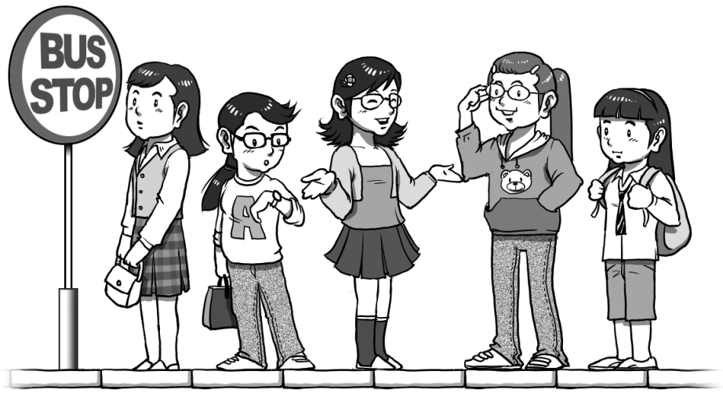

(1) (2) (3) (4) (5)

M : Wow, what a small world!

W : Really? Why is that?

M : I just saw the girl I met at Jane's birthday party yesterday.

W : Oh, really? Where is she?

M : Can you see that tall girl with glasses at the bus stop?

W : Yes. You mean the girl wearing jeans?

M : No. She's wearing a skirt.

10. 대화를 듣고, 여자가 전화를 건 목적을 고르시오. (4번)

① 숙제를 묻기 위해

② 안부를 묻기 위해

③ 약속을 변경하기 위해

④ 전화번호를 알아보기 위해

⑤ 전화 고장 신고를 하기 위해

M : Hello?

W : Hi! Tom. Did I wake you up?

M : No. I was awake. What's up?

W :I need to call Jane, but I don't have her phone number. I'm wondering if you have it.

M : OK. Let me check. Hold on......Sorry, I don't have her number.

W : All right. I'll ask Jake. Bye.

11. 대화를 듣고, 남자가 지불해야 할 금액을 고르시오. (4번 - $25)

① $10 ② $15 ③ $20 ④ $25 ⑤ $30

W: May I help you?

M: Yes, I'm looking for a tie.

W: How about this one?

M: It looks great. How much is it?

W: It's $10.

M: OK. Can I see that blue one, too?

W: Sure. It's very popular.

M: How much is it?

W: It's $15. Which one would you like?

M: I'll take both of them.

12. 다음을 듣고, 설명하는 손의 모양을 고르시오. (2번)

|  |  |  |  |  |
| --- | --- | --- | --- | --- |
| (1) | (2) | (3) | (4) | (5) |
| EMB00000e2012b6 | EMB00000e2012b7 | EMB00000e2012b8 | EMB00000e2012b9 | EMB00000e2012ba |

A gesture is a movement of the hands, arms or head to express an idea or feeling. For example, to show that something or somebody is the best, people usually use this hand gesture. Just make a fist and put up your thumb. It's very easy to do this gesture, isn't it?

13. 대화를 듣고, 여자가 구입한 물건을 고르시오. (1번)

|  |  |  |  |  |
| --- | --- | --- | --- | --- |
| (1) | (2) | (3) | (4) | (5) |
| EMB00000e2012bb | EMB00000e2012bc | EMB00000e2012be | EMB00000e2012bd | EMB00000e2012bf |

M: Where did you go yesterday?

W: Well, I went to Insadong with my friends.

M: What did you do there?

W: I saw lots of things such as masks, paper fans and oil lamps.

M: Did you buy anything?

W: I bought a Korean mask. I'm interested in mask dances.

14. 대화를 듣고, 현재 시각을 고르시오. (2번)

|  |  |  |  |  |
| --- | --- | --- | --- | --- |
| ① |  |  | ② |  |
| EMB00000e2012c0 | EMB00000e2012c0 |
|  |  |
|  |  |  |  |  |
| ③ |  |  | ④ |  |
| EMB00000e2012c0 | EMB00000e2012c0 |
|  |  |
|  |  |  |  |  |
| ⑤ |  |  |  |  |
| EMB00000e2012c0 |  |
|  |  |

W: Mike! Have you seen Minho around?

M: No. Are you waiting for him?

W: Yes. I'm supposed to meet him here at six.

M: Well, it's not six yet.

W: What time is it now?

M: It's fifteen to six.

15. 대화를 듣고, 남자의 마지막 말에 대한 여자의 응답으로 알맞은 것을 고르시오.

① It's 51,200 won.

② Have a nice trip.

③ It's about 440km.

④ It takes about three hours.

⑤ It is a good place for a vacation.

W : How can I help you?

M : I'd like to buy a ticket to Busan. When does the next KTX leave?

W : At 8:35, sir.

M : That's good. How long does it take to Busan?

16. 대화를 듣고, 여자의 마지막 말에 대한 남자의 응답으로 알맞은 것을 고르시오.

① I like rock music.

② Musicians are kind.

③ Jazz is my favorite.

④ I want to buy a guitar.

⑤ I listen to the radio everyday.

M : Hi, what are you doing?

W : Listening to music. I bought a jazz CD yesterday.

M : Is it good?

W : It's great! Do you like jazz?

M : No. I don't like jazz.

W : Then, what kind of music do you like?

**2005년 국가수준 학업성취도 평가 영어 (A형)**

17. 대화를 듣고, 무엇에 관한 대화인지 알맞은 것을 고르시오. (2번 – 건강단련하기)

① 게임하기 ② 건강단련하기 ③ 사진찍기④ 친구 사귀기

⑤ 아이 돌보기

W: Do you work out?

M: No, but I'm going to start lifting weights. How about you?

W: I'm taking an aerobics class. And aerobics is very good for you.

M: I've never tried aerobics.

W: You should do it three times a week if you want to be in good shape.

18. 대화를 듣고, 여자의 기분을 가장 잘 나타낸 것을 고르시오. (1번 – 분노)

① 분노 ② 슬픔 ③ 만족 ④ 불안 ⑤ 기쁨

M: How have you been lately?

W: Not so good.

M: What's up?

W: The young man living next door to me plays loud rock music every night till late. I can't get to sleep because of the noise.

M: Why don't you talk to him about it?

W: You're right. I can't stand it any more.

19. 대화를 듣고, 두 사람이 오늘 저녁에 할 일로 가장 알맞은 것을 고르시오. (3번 – 비디오 보기)

① 쇼핑하기 ② 산책하기 ③ 비디오 보기 ④ 수영하기 ⑤ 자전거 타기

M: How about going for a bike ride?

W: It's too hot for riding bikes.

M: How about a swim?

W: Well, I'm too tired to exercise.

M: Well, what do you want to do?

W: I'd prefer to rent a video. What about that?

M: Watching a movie at home sounds like a good idea.

20. 대화를 듣고, 남자가 여자 친구에게 줄 선물을 고르시오. (3번 – 반지)

① 귀걸이 ② 목걸이 ③ 반지 ④ 향수 ⑤ 팔찌

W: Good afternoon, sir. May I help you?

M: I'm looking for a gift for my girlfriend.

W: Have you thought about jewelry?

M: Like what?

W: Well, look at this necklace. It's simple but very pretty.

M: It's pretty, but I really can't spend that much money.

W: Well, have you thought about giving her a ring. It's not that expensive.

M: I think I will do that. Thanks for your help!