**1.** 그림의 빈칸 (A)에 들어갈 말로 적절하지 않은 것은?

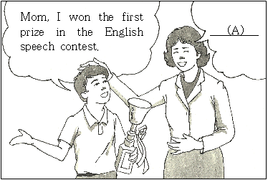

① Good job.

② No problem.

③ Good for you.

④ Congratulations!

⑤ How wonderful!

**2.** 다음 글의 빈칸에 들어갈 말로 가장 적절한 것은?

|  |
| --- |
| Walking on the street at night can be very _________. Drivers can’t see you very well. When you go out at night, you should wear bright colored clothes. You must also walk on the sidewalk, not on the road. |

① boring

② exciting

③ important

④ dangerous

⑤ comfortable

**3.** 다음 글에 드러난 글쓴이의 심정으로 가장 적절한 것은?

|  |
| --- |
| The rainstorm went away. I opened the window. I saw the sunlight coming through it. I looked outside. There were no more dark clouds. My family and my neighbors were all safe.  *rainstorm: 폭풍우 |

① upset

② happy

③ lonely

④ scared

⑤ worried

**4.** 다음은 사전에서 ‘take’의 뜻을 찾은 것이다. 빈칸에 들어갈 예문으로 가장 적절한 것은?

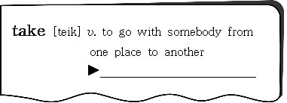

① I will **take** the blue cap.

② She’ll **take** you home by car.

③ Could you **take** a picture of me?

④ She is planning to **take** a computer class.

⑤ It’ll **take** about 2 hours to get to the airport.

**5.** 다음 글의 내용과 그림의 순서가 일치하도록, 주어진 (A), (B), (C)를 바르게 배열한 것은?

|  |
| --- |
| Jenny found a wallet on the street. She saw some money in the wallet. She thought about buying a T-shirt. On her way to the clothing store, she saw the police station. And she thought about what to do.  *wallet: 지갑 |

|  |  |  |
| --- | --- | --- |
| EMB000007f02ce0 | | |
| 󰀻 | | |
| EMB000007f02ce1 | | |
| 󰀻 | | |
| (A) | (B) | (C) |
| DRW000007f02cf5EMB000007f02ce4DRW000007f02cf7 | | |

① (A) - (B) - (C)

② (A) - (C) - (B)

③ (B) - (A) - (C)

④ (B) - (C) - (A)

⑤ (C) - (B) - (A)

**6.** 밑줄 친 They[they]가 가리키는 대상이 나머지 넷과 다른 것은?

|  |
| --- |
| Dogs have helped blind people for many years. But ①they are not the only helper animals. There are also guide horses. ②They can help blind people to get where they want to go. ③They are better than dogs for people who do not want to keep their guide animals in the house. Plus, ④they live a lot longer than dogs. ⑤They can live up to 40 years. |

**7.** 편지에 나타난 글쓴이의 의도로 가장 적절한 것은?

|  |
| --- |
| Dear John,  I had the same problem. I watched too much TV. My mother wanted me to stop, but I couldn’t. One day she surprised me with a new bike! At first I didn’t like to ride it. As time passed by, I could ride faster than before. Bike riding became fun. Now I don’t watch TV a lot. I hope my story will help you. Why don’t you try it?  Your friend,  *Mike* |

① 사과

② 감사

③ 제안

④ 초대

⑤ 축하

**8.** 다음은 봄 음악 축제의 프로그램이다. 주어진 질문에 대한 답으로 가장 적절한 것은?

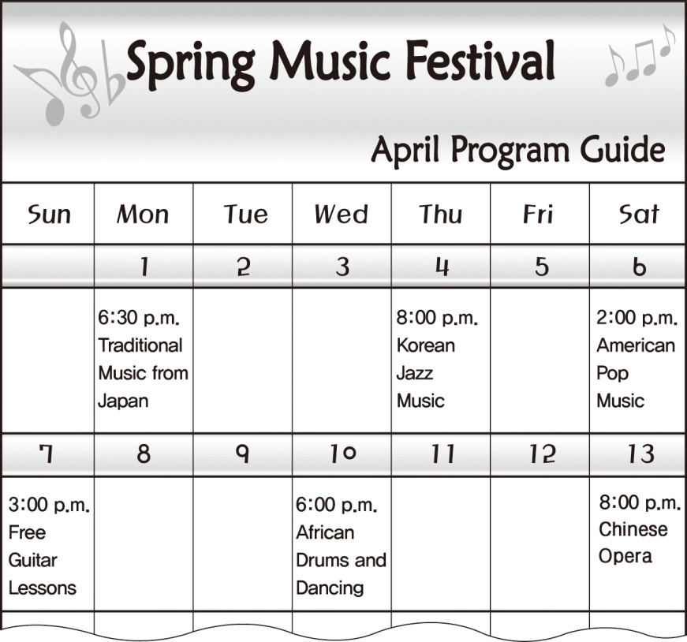

*Question*: Sumi is interested in African dancing and American music. She has free time only on weekends. What date is best for her?

① April 1

② April 6

③ April 7

④ April 10

⑤ April 13

**9.** 다음 글에서 전체 흐름과 관계 없는 문장은?

|  |
| --- |
| Can you imagine your life without energy? Our lives would be different without it. Energy is very important in our lives. ①It does many things for us. ②Energy gives us the power to turn on our light. ③It keeps our food fresh. ④There are many ways to get energy. ⑤It also keeps us warm and cool. |

**10.** 다음 글에서 밑줄 친 ‘Give your mom the day off’의 방법으로 제시된 것을 그림으로 나타낸 것은?

|  |
| --- |
| Give your mom the day off on Mother’s Day. Let your mom sleep in. Go into the kitchen and prepare her favorite meal. When everything is ready, bring it to her bedroom carefully. Don’t forget the flowers and cards. She’ll really like it. |

|  |  |  |
| --- | --- | --- |
| ① |  | ② |
| EMB000007f02ceb |  | EMB000007f02cec |
|  |  |  |
| ③ |  | ④ |
| EMB000007f02ced |  | EMB000007f02cee |
|  |  |  |
| ⑤ |  |  |
| EMB000007f02cef |  |  |

**11.** 다음 시의 빈칸에 들어갈 말로 적절하지 않은 것은?

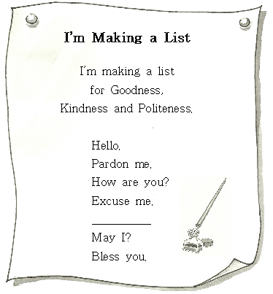

① Go away.

② I’m sorry.

③ Good luck.

④ Could you?

⑤ Thank you.

**12.** 글의 흐름으로 보아, 주어진 문장이 들어가기에 가장 적절한 곳은?

|  |
| --- |
| She helped me to prepare for the test. |

|  |
| --- |
| I had a science test the following day. ( ① ) But I left my textbook at school. ( ② ) How was I going to study for the test? ( ③ ) I was getting nervous. ( ④ ) My older sister saw that I was worried. ( ⑤ ) So, I was ready for the test and I got an A. |

**13.** 다음 글의 제목으로 가장 적절한 것은?

|  |
| --- |
| For a whole day, forget about the clock. Eat when you’re hungry, and sleep when you’re tired. What do you think will happen? Don’t be surprised! Your day will be almost the same. You’ll get hungry at the time you usually eat. You’ll be tired at the time you usually sleep. Your body knows what time it is. |

① Daily Life

② Body Clock

③ Alarm Clock

④ Eating Habits

⑤ Sleeping Time

**14.** (A), (B)의 관계로 보아, 빈칸에 들어갈 문장으로 가장 적절한 것은?

|  |  |  |
| --- | --- | --- |
| (A) |  | (B) |
| Bill lost his puppy. | ⇨ | He felt sad. |
| Bill got up late this morning. | ⇨ | He was late for school. |
| Bill didn’t wear gloves as he made a snowman. | ⇨ |  |

① He lost his gloves.

② It stopped snowing.

③ His hands got very cold.

④ The snowman was wearing a hat.

⑤ Everything was covered with snow.

**15.** 다음 글을 도표로 나타낼 때, (A), (B), (C)에 해당하는 것으로 가장 적절한 것은?

|  |
| --- |
| About 3.7million animals were used in scientific experiments in England last year. Most of the scientific experiments were done on mice. Fish and birds were also used, but fish were more used than birds.  *experiment: 실험 |

|  |
| --- |
| Animal Use |
| EMB000007f02cf0 |

|  |  |  |  |  |  |  |
| --- | --- | --- | --- | --- | --- | --- |
|  | (A) |  | (B) |  | (C) |  |
| ①  ②  ③  ④  ⑤ | fish  fish  mice  mice  birds |  | mice  birds  fish  birds  fish |  | birds  mice  birds  fish  mice |  |

16. 다음 빈칸에 들어갈 말로 가장 적절한 것은? [2점]

J im: Can I use your MP3 player?

Dan: Sure. _________________

J im: Thank you.

Dan: You’re welcome.

① Pardon me?

② That’s right.

③ Here you are.

④ I’m afraid not.

⑤ That’s too bad.

17. ‘ I ’의 직업으로 가장 적절한 것은?

My job is very interesting. I can play many

different roles. I can be a teacher, a doctor, or a

president. I have lots of fans. You can see me on

the screen. What am I?

* president: 대통령

① an actor ② a nurse

③ a writer ④ a dentist

⑤ a pianist

18. 다음 글의 내용과 그림의 순서가 일치하도록, 주어진

그림 (A), (B), (C)를 알맞게 배열한 것은?

Last night, I had to study for a test. My cat,

Dona, came to me and cried. So, we played with a

ball. Later, she cried again and looked hungry. I

gave her some food, and she was happy. But then,

she cried all night, and I couldn’t study at all.

Today, I got a bad score on the test.

|  |  |  |
| --- | --- | --- |
| (A) | (B) | (C) |
|  |  |  |

① (A) - (B) - (C)

② (A) - (C) - (B)

③ (B) - (A) - (C)

④ (C) - (A) - (B)

⑤ (C) - (B) - (A)

19. 다음 대화 중 자연스럽지 않은 것은? [4점]

① A: May I speak to Mr. Brown?

B: He is out now. Can I take your message?

② A: How do you go to school?

B: I walk to school.

③ A: How often do you watch movies?

B: Once a month.

④ A: I got an ‘A’ on my math test.

B: Good job.

⑤ A: What do you do?

B: I’m writing a letter.

20. 다음 조리법으로 만들 수 있는 음식으로 가장 적절한

것은?



① soup ② salad

③ sandwich ④ steak

⑤ spaghetti