***중 1 읽기***

***1.*** 다음 명함에서 알 수 있는 내용이 아닌 것은?

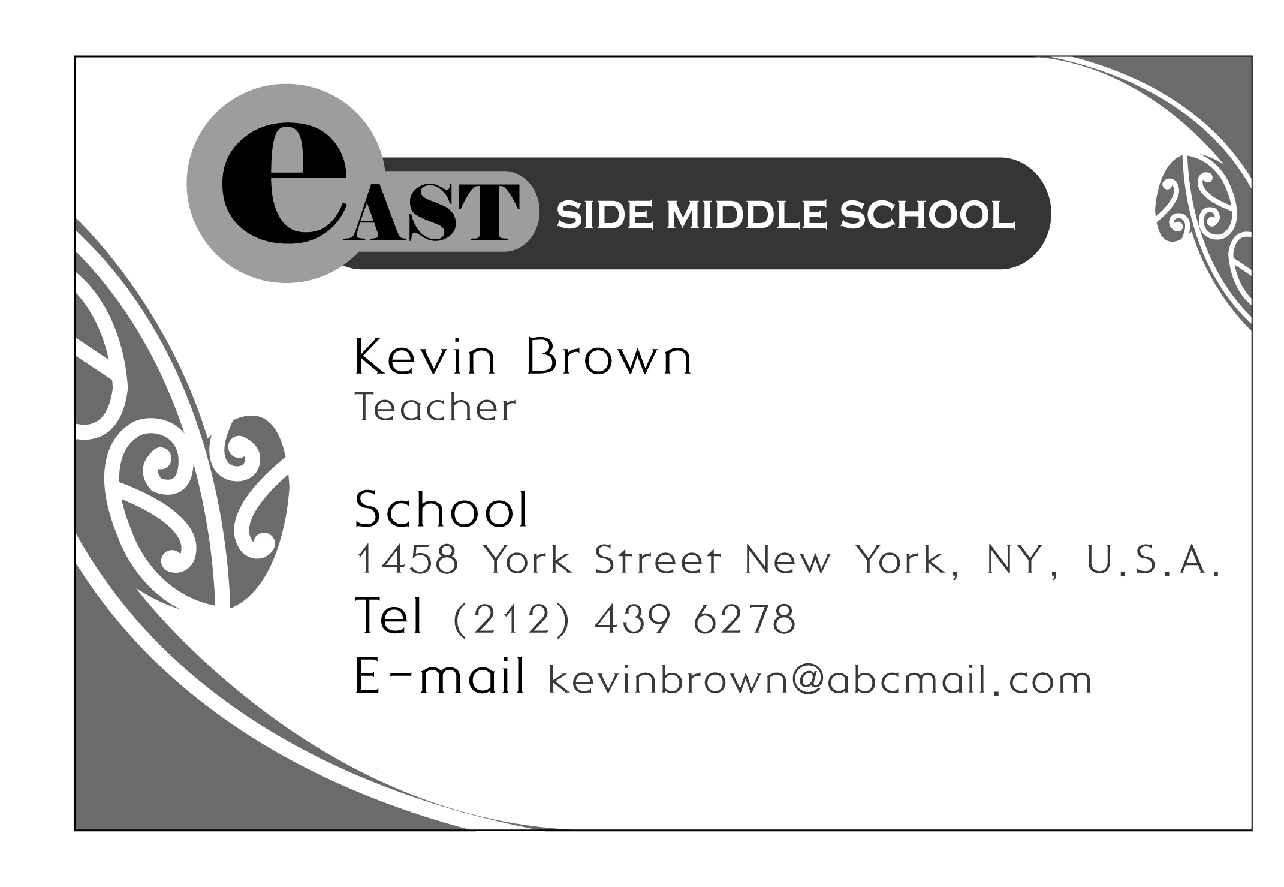

① 직업은 음악가이다.

② 직장은 미국에 있다.

③ 이름은 Kevin Brown이다.

④ 전화번호는 212 439 6278이다.

⑤ 이메일 주소는 kevinbrown@abcmail.com이다.

***2.*** 글의 내용으로 보아, 글쓴이가 두 번째로 간 곳은?

|  |
| --- |
| Yesterday, I was sick. So I went to a hospital. And then I visited my mother. She sells books at a bookstore. It is near the toy shop. I came back home by bus. |

① home② hospital③ bookstore

④ toy shop⑤ bus stop

***3.*** 지수에게 아래의 문자 메시지를 보낸 이유로 알맞은 것은?

|  |  |
| --- | --- |
| EMB00000ba8bb5a | ① 숙제를 잘 몰라서  ② 병원 예약을 부탁하려고  ③ 학교에 늦는다고 전해 달라고  ④ 약속 시간을 다시 정하기 위해서  ⑤ 선생님의 전화번호를 묻기 위해서 |

***4.*** 아래 표의 내용을 바르게 설명한 문장은?

|  |  |  |
| --- | --- | --- |
| 이름 | 나이 | 키 |
| Mike | 15세 | 160cm |
| Tony | 15세 | 162cm |
| Kevin | 14세 | 157cm |

① Tony is older than Mike.

② Kevin is older than Mike.

③ Kevin is older than Tony.

④ Mike is taller than Tony.

⑤ Tony is taller than Kevin.

***5.*** 다음 알파벳 띠에서 찾을 수 없는 달(month)은?

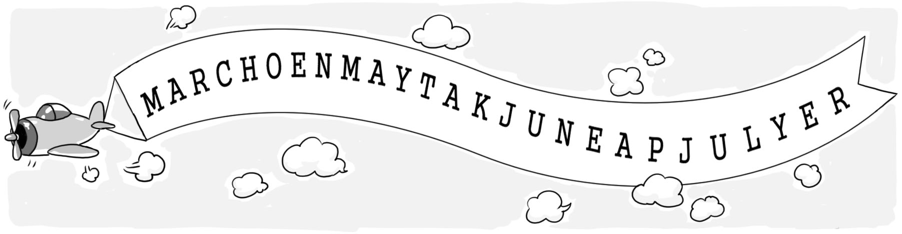

1. 3월② 5월③ 6월④ 7월⑤ 11월

***6.*** 대․소문자나 문장 부호의 쓰임이 바른 것은?

|  |
| --- |
| ①dear Eric,  Hello, my name is Kim, Mina. ②I live in Seoul, Korea. I'm 14 years old. ③I like singing and dancing?  ④I want to know About you. Please write me back.  ⑤Bye?  *Mina* |

***7.*** 밑줄 친 부분의 쓰임이 잘못된 것은?

|  |
| --- |
| EMB00000ba8bb5b  This is my father. ①He is a pilot. This is my mother. ②She is a doctor. This is my sister, Amy. ③He is a student. ④Her hobby is playing the piano. I love ⑤my family. |

***8.*** ( ) 안의 낱말을 순서에 맞게 나열한 것은?

|  |
| --- |
| Sam: Welcome! Come in.  Yuri: Thanks.  Sam: Oh, (**don't/shoes/take/your/off**).  Yuri: Okay, I see. |

① don't off take your shoes

② don't off take shoes your

③ don't your shoes take off

④ don't your shoes off take

⑤ don't take off your shoes

***9.*** 밑줄 친 ⓐ～ⓓ 그 어디에도 사용할 수 없는 낱말은?

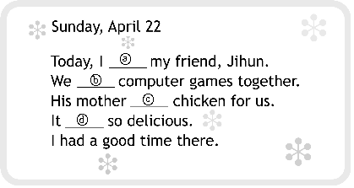

|  |  |  |  |  |  |  |  |  |  |  |  |  |
| --- | --- | --- | --- | --- | --- | --- | --- | --- | --- | --- | --- | --- |
| ① |  |  | |  | ② |  |  |  | ③ |  |  |  |
|  | **was** | |  |  | **cooked** |  |  | **visited** |  |
|  |  | |  |  |  |  |  |  |  |
| ④ |  |  |  | | ⑤ |  |  |  |  |  | | |
|  | **went** |  | |  | **played** |  |
|  |  |  | |  |  |  |

**10.** 빈칸에 들어갈 제목으로 가장 적절한 것은?

|  |
| --- |
| _____________________  ◦ Keep your room and classroom bright.  ◦ After you use a computer, take a break.  ◦ When you read a book, keep the book 30cm away from you. |

① When to Take a Break

② How to Use Computers

③ How to Choose Good Books

④ What to Do with the Internet

⑤ How to Take Care of Your Eyes

**11.** 다음과 같이 낱말 퍼즐을 완성할 때, 빗금 친 곳에 들어갈 단어를 그림으로 나타낸 것은?

|  |  |  |  |  |  |  |
| --- | --- | --- | --- | --- | --- | --- |
| |  |  |  |  |  |  | | --- | --- | --- | --- | --- | --- | | f | a | m | i | l | y |   father, mother, sister ⇒ |

|  |  |  |  |  |  |  |  |
| --- | --- | --- | --- | --- | --- | --- | --- |
| ◦ arm, head, leg ⇒ | | b |  |  |  |  | |
| ◦ lily, rose, tulip ⇒ | | f |  |  |  |  |  |
| ◦ green, red, yellow ⇒ | c |  |  |  |  |  | |
| ◦ golf, soccer, tennis ⇒ | s |  |  |  |  |  |  |

|  |  |  |  |  |
| --- | --- | --- | --- | --- |
| ① | EMB00000cbc003b |  | ② | EMB00000cbc003c |
| ③ | EMB00000cbc003d |  | ④ | EMB00000cbc003e |
| ⑤ | EMB00000cbc003f |  |  |  |

**12.** 다음 글에서 ‘I’의 심정 변화로 가장 적절한 것은?

|  |
| --- |
| I watched the 2010 World Cup on TV last summer. When Korea lost the game against Argentina, I was sad. I thought Korea lost their chance for the final 16. But in the next game with Nigeria, Korea made history! The Korean team made it to the final 16! I almost cried with joy. |

|  |  |  |  |
| --- | --- | --- | --- |
| ① | sad | → | excited |
| ② | bored | → | afraid |
| ③ | unhappy | → | sad |
| ④ | proud | → | happy |
| ⑤ | excited | → | angry |

**13.** 다음 대화의 빈칸에 들어갈 말로 가장 적절한 것은?

|  |
| --- |
| Billy : Which club did you join?  Susan: I joined the Cooking Club. I like cooking. Which club did you join?  Billy : I joined the Book Club.  Susan: What do you usually do in the club?  Billy : _______________________________ |

① I want to join the club.

② I have a lot of books in my room.

③ My favorite book is *Harry Potter*.

④ We read books and talk about them.

⑤ There are many books in the library.

**14.** 다음은 Mike가 쓴 글이다. 글의 내용과 일치하지 않는 것은?

|  |
| --- |
| My name is Mike. I’m 13 years old and I’ll be 14 on May 17th. I was born and still live in Texas, U.S.A. I’d like to make friends from other countries. I enjoy playing basketball and swimming. I want to be a basketball player. Please e-mail me: *happy123@hmail.com* |

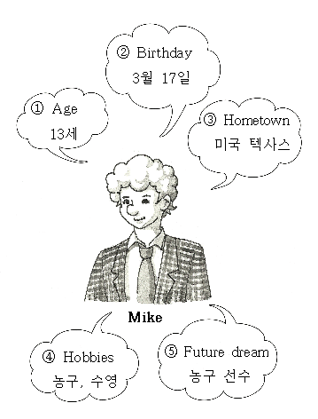

**15.** 다음 광고문의 내용과 일치하는 것은?

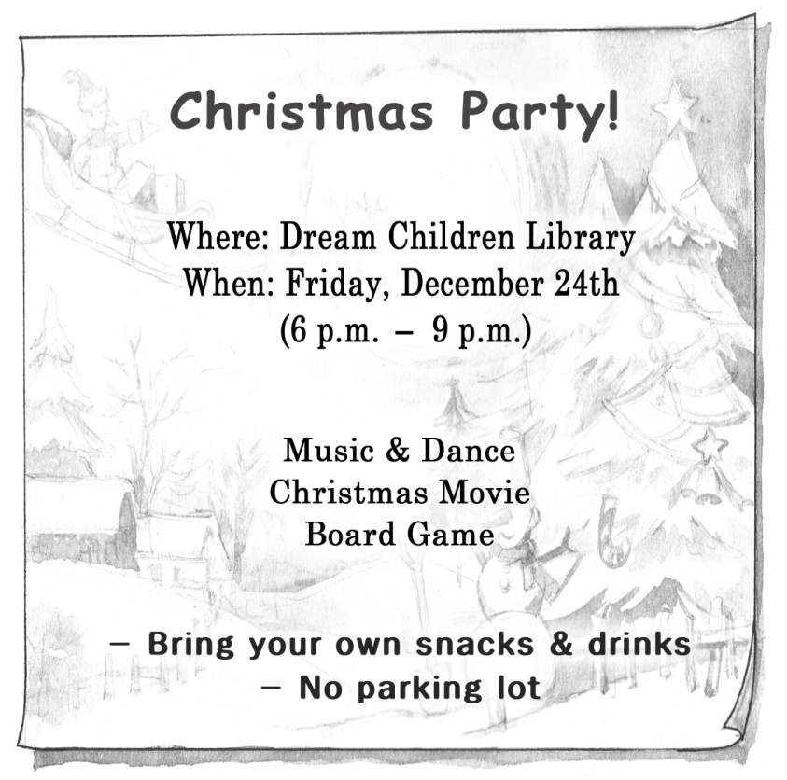

① 어린이 영화관에서 열리는 행사이다.

② 행사는 크리스마스 날 저녁에 열린다.

③ 게임은 준비되어 있지 않다.

④ 음료수만 가져올 수 있다.

⑤ 주차 공간은 마련되어 있지 않다.

**16.** 밑줄 친 It[it]이 가리키는 대상이 나머지 넷과 다른 것은?

|  |
| --- |
| My daughter has a rabbit named Rose. ①It is the first pet in her life. She likes to play with ②it in the yard. She gives a carrot to ③it every day. Rose really likes ④it. When she comes home, she always runs to Rose. ⑤It is her best friend. |

**17.** 다음은 Sumi가 응답한 설문 조사를 글로 옮긴 것이다. 빈칸 (A)와 (B)에 들어갈 말로 가장 적절한 것은?

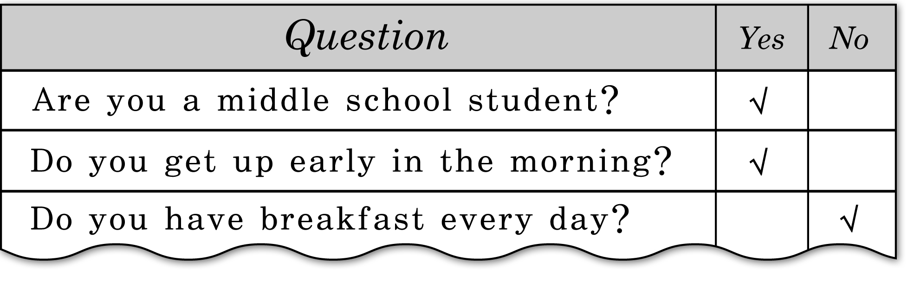

|  |
| --- |
| Sumi is a middle school student. She (A) early in the morning, but she (B) breakfast every day. |

|  |  |  |
| --- | --- | --- |
|  | (A) | (B) |
| ① | get up | don’t have |
| ② | gets up | doesn’t have |
| ③ | gets up | has |
| ④ | don’t get up | doesn’t have |
| ⑤ | doesn’t get up | have |

**18.** 주어진 글 다음에 이어질 내용을 바르게 나열한 것은?

|  |
| --- |
| Clouds fly over the mountains. Day by day, the clouds grow larger. |

|  |
| --- |
| (A) At last, the rivers make the sea.  (B) Little by little, rain begins to fall.  (C) The rain runs into rivers. |

① (A) - (B) - (C)

② (B) - (A) - (C)

③ (B) - (C) - (A)

④ (C) - (A) - (B)

⑤ (C) - (B) - (A)

**19.** 다음 글에서 Tom과 James를 통해 배울 수 있는 점으로 가장 적절한 것은?

|  |
| --- |
| One day Tom and James went hiking. About 30 minutes later Tom said, “It’s very hot. I can’t walk any more.” Then James said, “Come on! We’re almost at the top. Don’t give up.” They kept on hiking. Finally they arrived at the top of the mountain. Tom said, “What a great view! We did it!” |

① 질서

② 정직

③ 인내

④ 절약

⑤ 효도

**20.** 다음 그림에서 박물관 직원이 가리키고 있는 표지판으로 가장 적절한 것은?

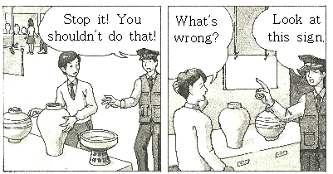

|  |  |  |  |  |
| --- | --- | --- | --- | --- |
| ① | EMB00000cbc0045 |  | ② | EMB00000cbc0046 |
| ③ | EMB00000cbc0047 |  | ④ | EMB00000cbc0048 |
| ⑤ | EMB00000cbc0049 |  |  |  |