***중 1***

***1.*** 자연스러운 대화가 되도록 문장의 순서를 바르게 배열한 것은?

|  |
| --- |
| (A) To Mt. *Jiri.*  (B) What do you want to do this Saturday?  (C) That is a good idea. Where?  (D) I want to go camping. |

① (B)-(C)-(D)-(A)② (B)-(D)-(C)-(A)

③ (C)-(A)-(D)-(B)④ (C)-(B)-(D)-(A)

⑤ (D)-(B)-(C)-(A)

***2.*** 빈칸에 들어갈 말로 알맞은 것은?

|  |
| --- |
| A: I'll visit my uncle in *Busan* this winter.  ________________________  B: I will go hiking.  A: Good! |

① What's that?

② How are you?

③ How about you?

④ How kind of you!

⑤ Who is your uncle?

***3.*** 짝지어진 대화가 어색한 것은?

① A: How was the party?

B: It was fun.

② A: Where are you from?

B: I am a student.

③ A: When is Children's Day?

B: It is May 5.

④ A: Where is your classroom?

B: It is on the fourth floor.

⑤ A: What did you do yesterday?

B: I did my homework.

***4.*** 말주머니의 표현이 어색한 것은?

|  |  |  |  |
| --- | --- | --- | --- |
| ① | DRW0000090cb987 | ② | DRW0000090cb989 |
|  |  |  |  |
| ③ | DRW0000090cb98b | ④ | DRW0000090cb98d |
|  |  |  |  |
| ⑤ | DRW0000090cb98f |  |  |

***5.*** 민수의 생활 계획표를 보고 대화의 빈칸에 알맞은 시각은?

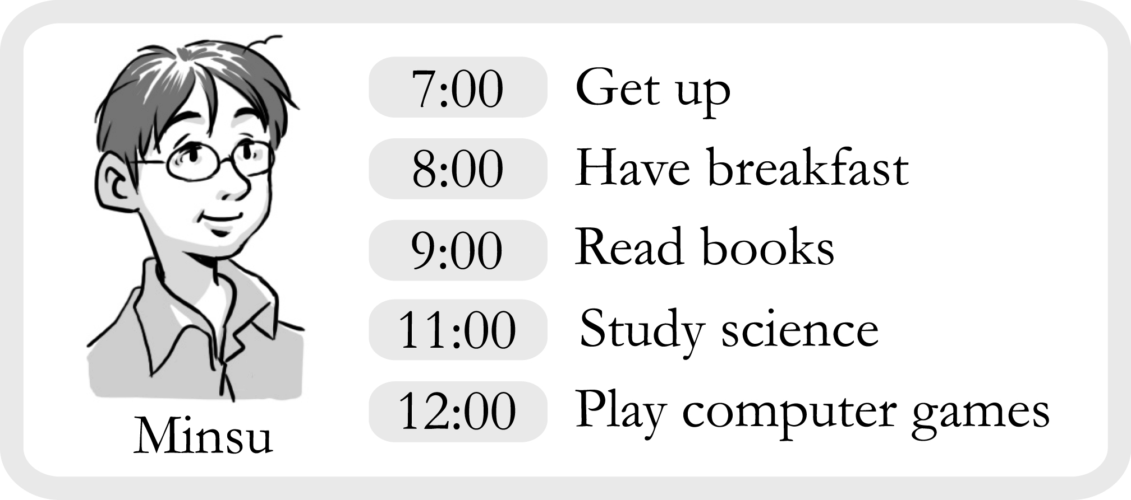

|  |
| --- |
| A: Minsu, what time do you read books?  B: I read books at o'clock. |

① seven② eight③ nine

④ eleven⑤ twelve

***6.*** 그림을 보고 바르게 표현한 문장은?

|  |  |  |
| --- | --- | --- |
| EMB0000090cb97b | EMB0000090cb97c | EMB0000090cb97d |

① Sora is older than Juri.

② Juri is older than Sora.

③ Mina is older than Sora.

④ Juri is younger than Mina.

⑤ Sora is younger than Mina.

***7.*** 밑줄 친 부분에 대한 설명으로 알맞지 않은 것은?

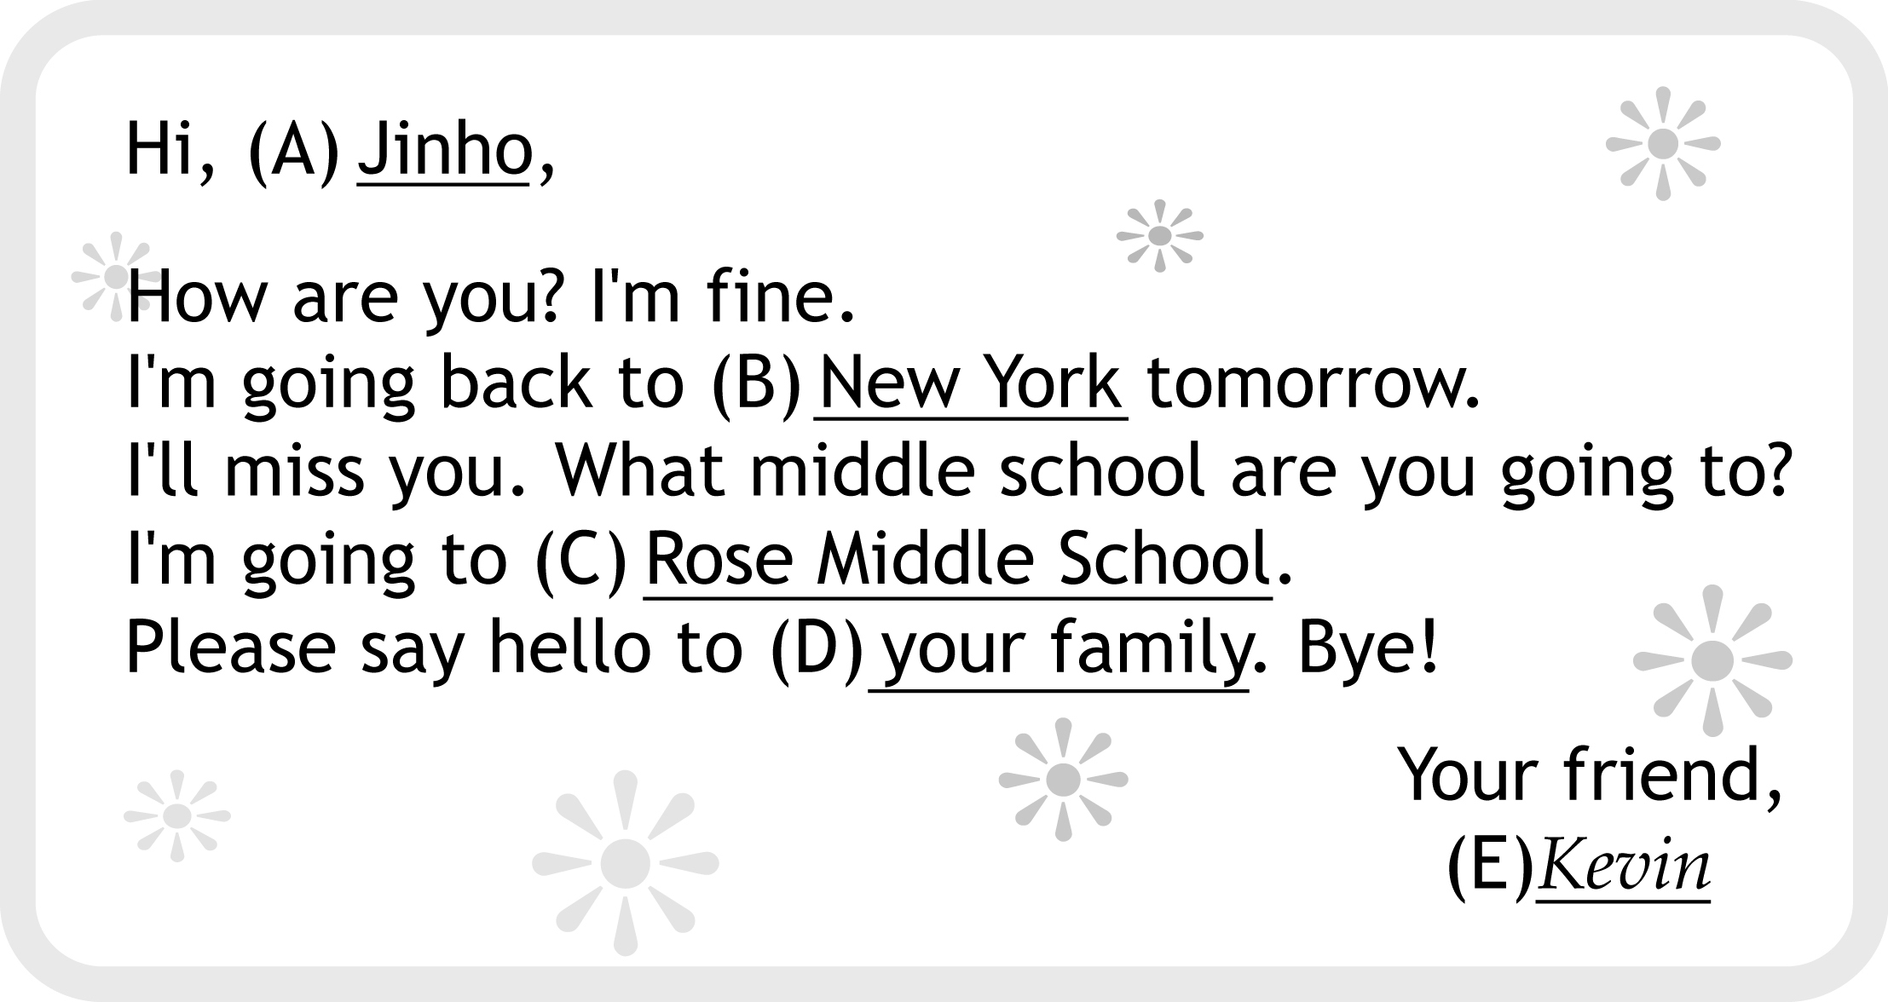

① (A) -편지를 받는 사람

② (B) - Kevin이 내일 돌아갈 곳

③ (C) - Kevin이 다닐 초등학교

④ (D) -진호의 가족

⑤ (E) -편지를 쓴 사람

***8.*** (A)와 (B)에 들어갈 말이 바르게 짝지어진 것은?

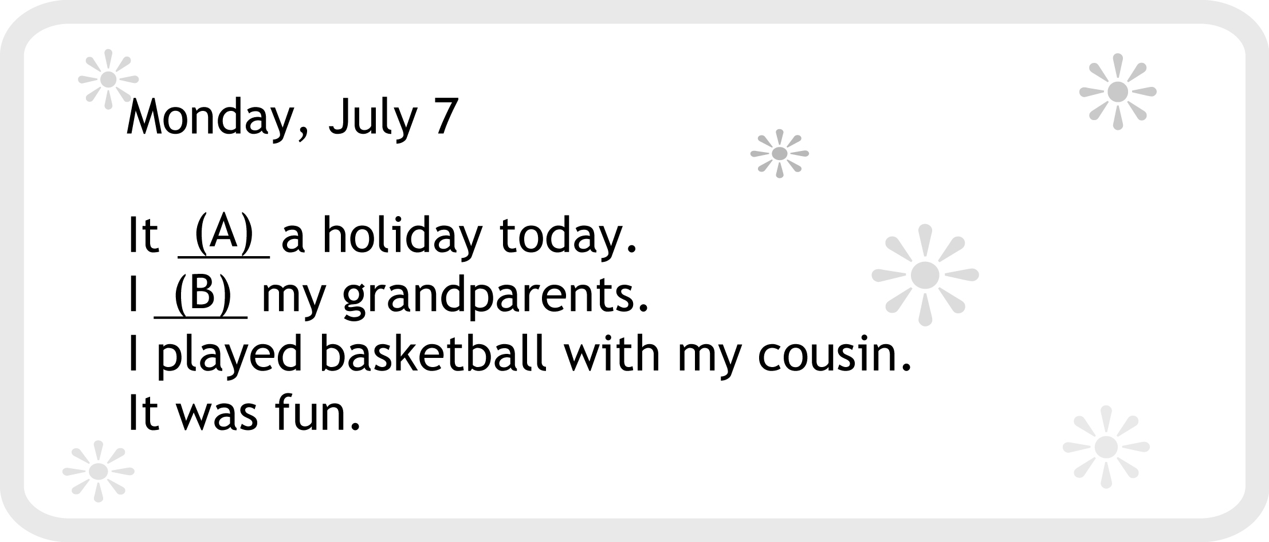

(A) (B)

① is go

② are put

③ are play

④ was did

⑤ was visited

***9.*** 주어진 문장이 들어가기에 가장 알맞은 곳은?

|  |
| --- |
| They brought beautiful flowers. |

( ① ) I was sick. ( ② ) I was at home all day. ( ③ ) My friends visited me. ( ④ ) I was happy. Now, I'm okay. ( ⑤ )

***10.*** 빈칸에 들어갈 말로 가장 알맞은 것은?

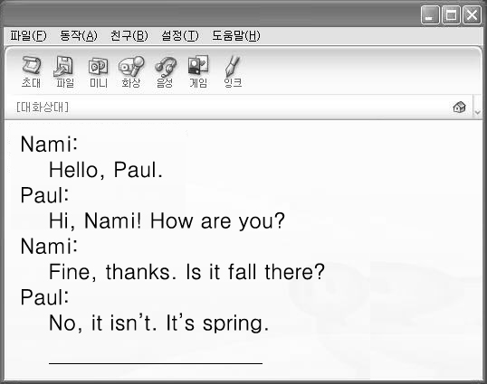

① We have *Chuseok.*

② Let's make a snowman.

③ We have a summer vacation.

④ Beautiful flowers are everywhere.

⑤ We can see red and yellow leaves.

***11.*** 대ㆍ소문자나 문장 부호의 쓰임이 바른 것은?

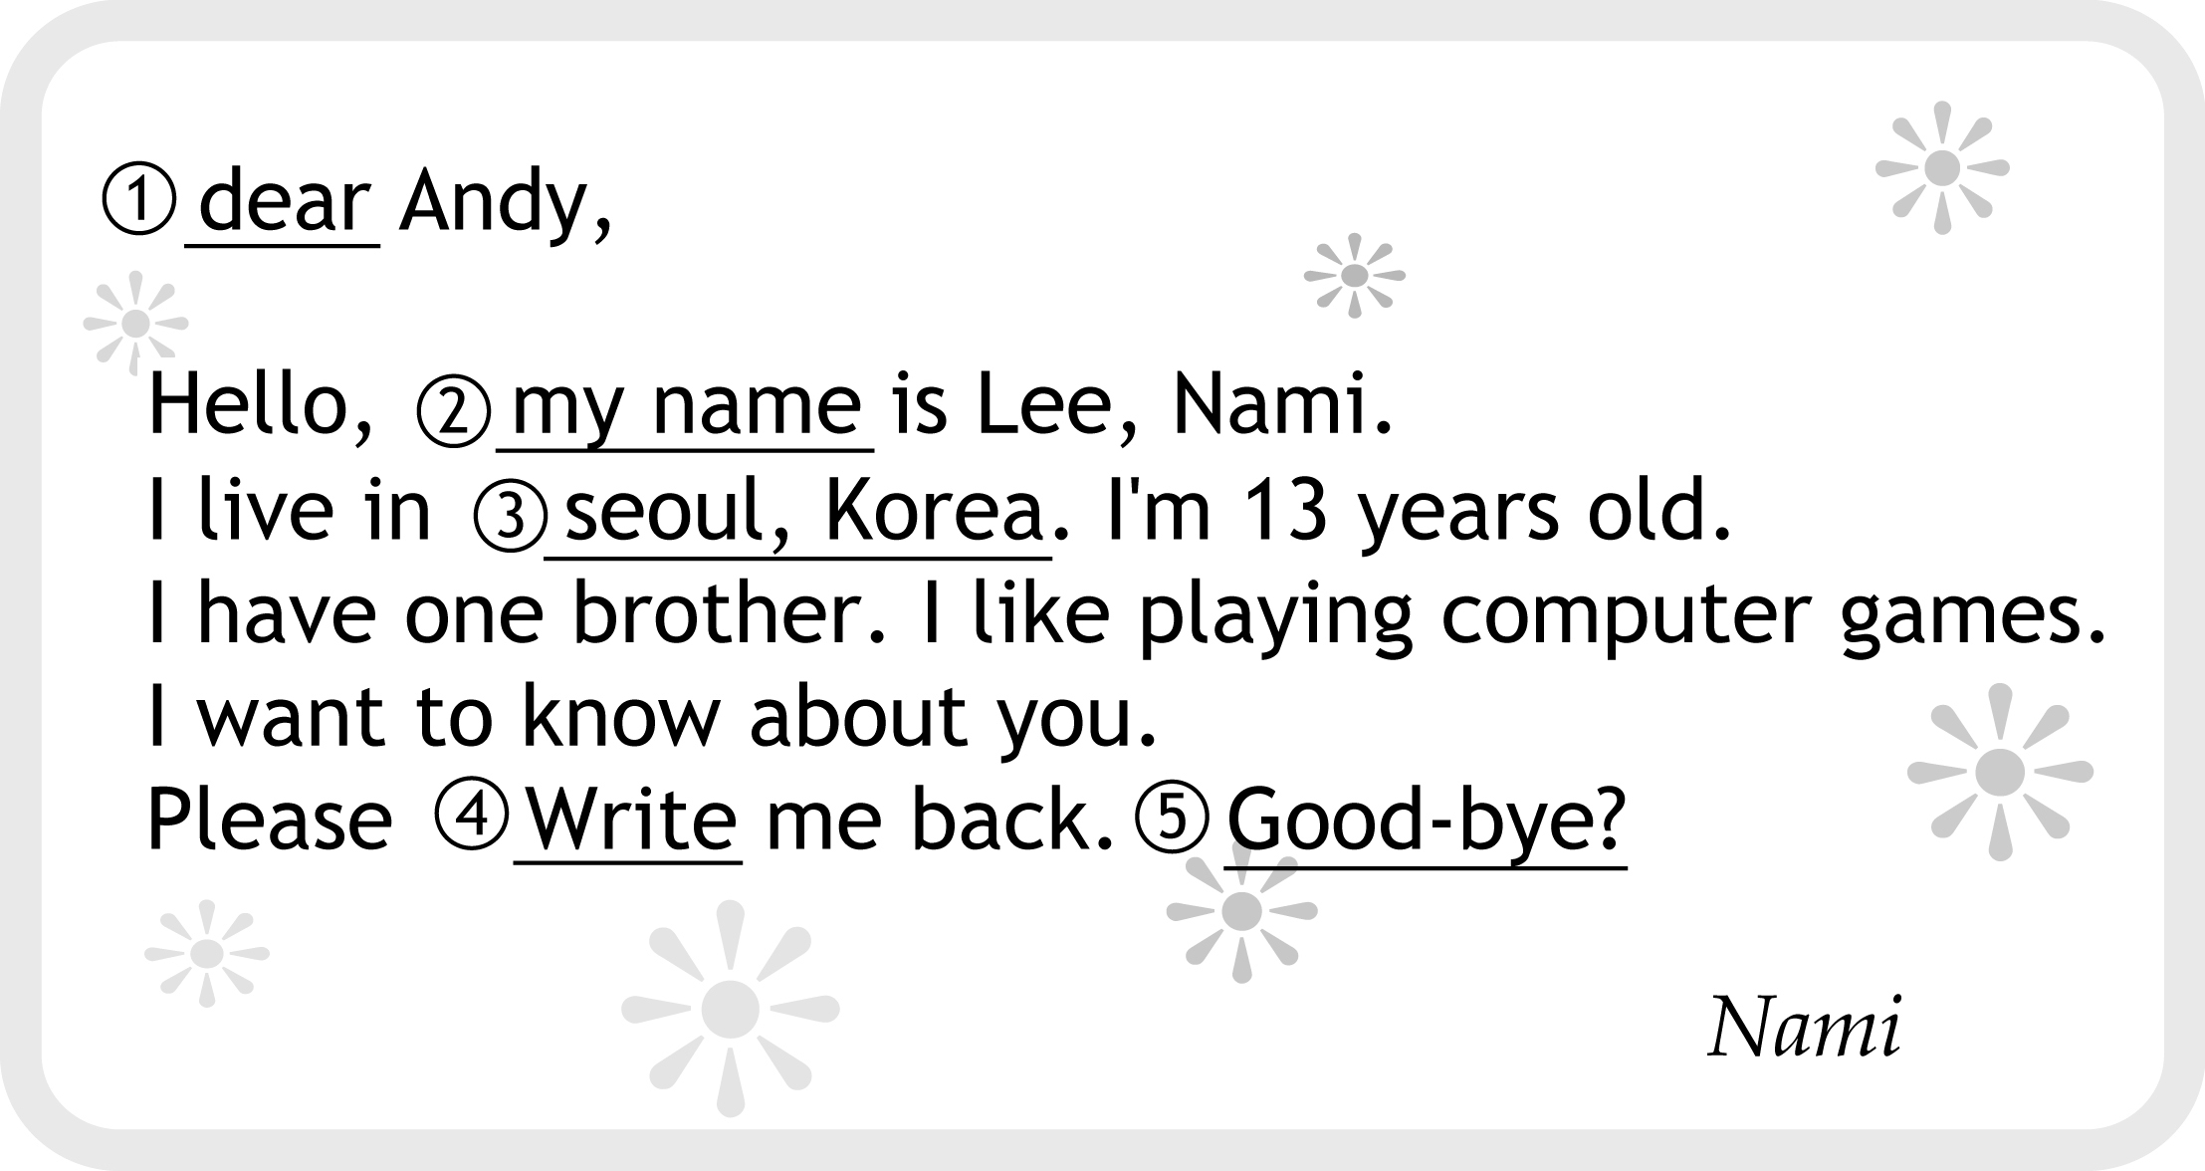

***12.*** 밑줄 친 부분과 같은 의미로 바꾸어 쓸 수 있는 것은?

|  |
| --- |
| A: I want to make a model plane.  Will you help me?  B: No problem. |

① No, I don't.

② Sure, I will.

③ Sorry, I can't.

④ That's too bad.

⑤ I have no idea.

***13.***다음 대화의 빈칸에 알맞은 대답은?

|  |
| --- |
| A: How much is this umbrella?  B: _____________________  A: OK. I'll take it. |

① I like it.

② Yes, it is.

③ It's too hot.

④ Here's your change.

⑤ It's seven dollars.

***14.*** 그림으로 보아, Tom과 Jane이 하고 싶은 일을 잘 표현한 것은?

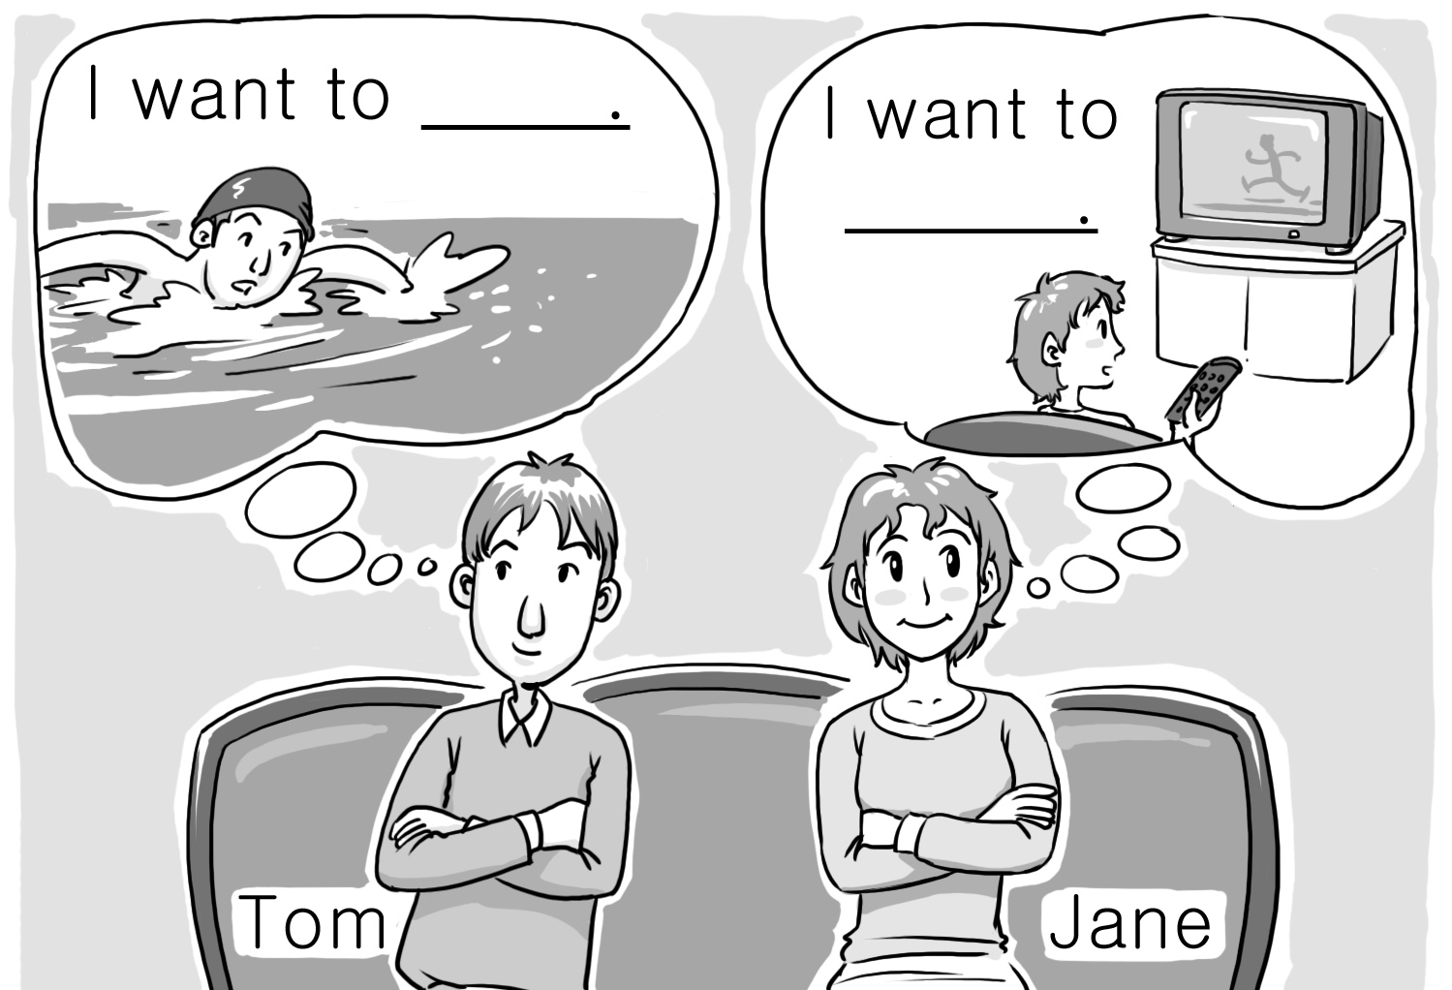

|  |  |  |
| --- | --- | --- |
|  | Tom | Jane |
| ① | swim | watch TV |
| ② | study | sleep |
| ③ | go hiking | sing |
| ④ | play soccer | dance |
| ⑤ | play the violin | drink water |

***15.*** 다음 상황에서 여자가 할 말로 알맞은 것은?

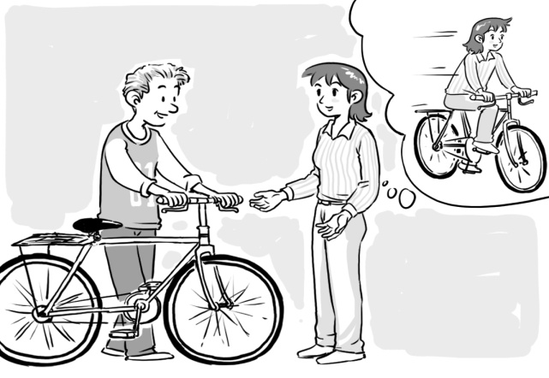

① Please be quiet.

② May I come in?

③ Can I ride your bike?

④ Let's play basketball.

⑤ Will you pass me the ball?

***16.*** 자연스러운 대화가 되도록 문장의 순서를 바르게 배열한 것은?

|  |
| --- |
| (A) May I help you?  (B) It's $ 30.  (C) How much is this bag?  (D) Yes, please. |

① (A) - (B) - (C) - (D)

② (A) - (C) - (B) - (D)

③ (A) - (C) - (D) - (B)

④ (A) - (D) - (C) - (B)

⑤ (A) - (B) - (D) - (C)

***17.*** 다음 대화의 밑줄 친 부분에 들어갈 말로 알맞은 것은?

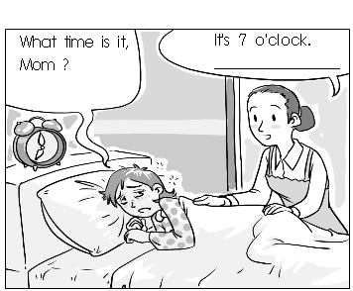

① It's time to sleep.

② It's time to get up.

③ It's time to go to bed.

④ It's time to have lunch.

⑤ It's time to come back.

***18.*** 그림으로 보아, 물음에 알맞게 응답한 사람은?

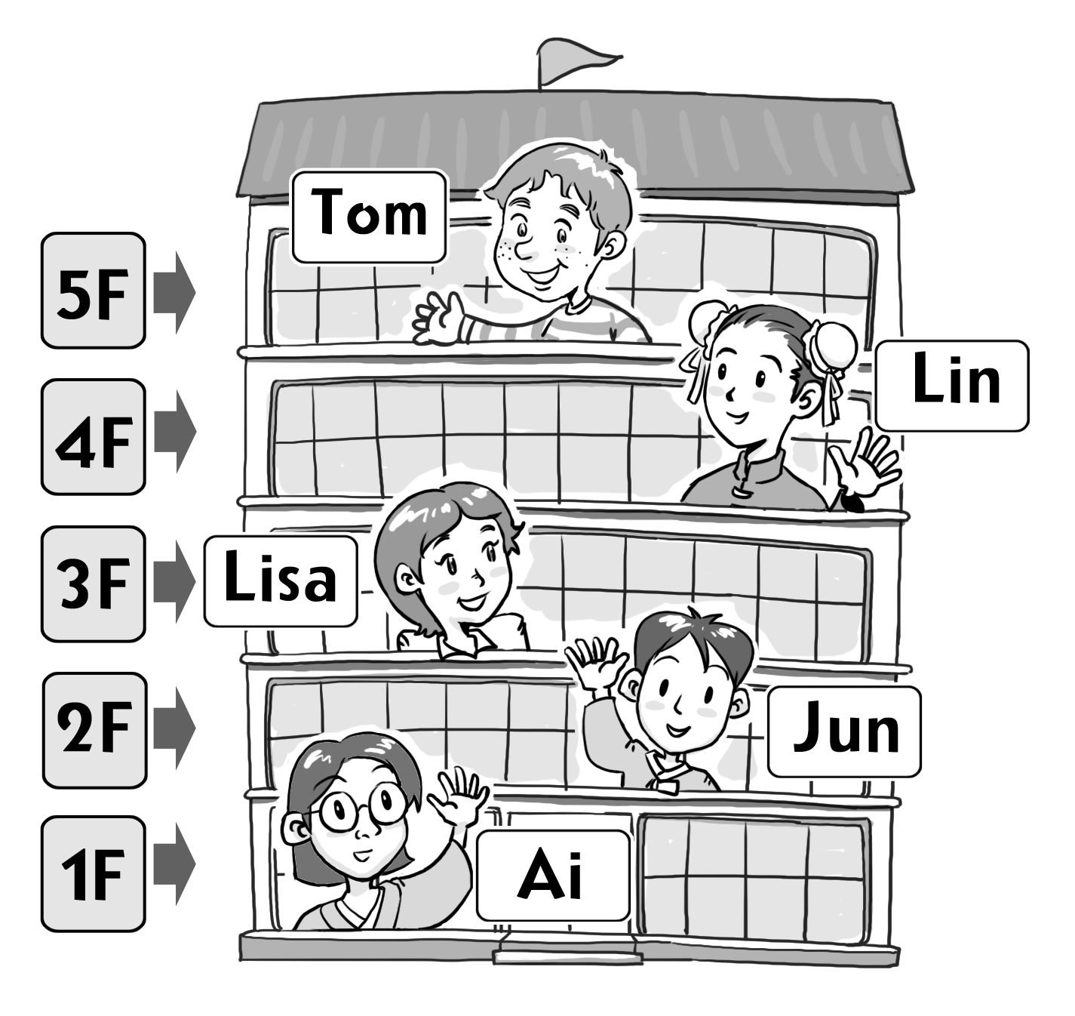

|  |
| --- |
| A : Where's your room?  B : |

① Ai : It's on the fifth floor.

② Jun: It's on the second floor.

③ Lisa: It's on the first floor.

④ Lin : It's on the third floor.

⑤ Tom: It's on the fourth floor.

***19.*** (A)를 (B)와 같은 대화로 바꿀 때, 빈칸에 들어갈 내용을 가장 잘 나타낸 그림은?

(A)

|  |
| --- |
| I'm John. Tomorrow is my mom's birthday. I want to cook for Mom. My brother, Tom will make a card. |

(B) 󰀻

|  |
| --- |
| John : Tomorrow is Mom's birthday.  Tom : Right. I will make a card.  What do you want to do for her?  John : ____________________________________. |

|  |  |  |  |  |  |
| --- | --- | --- | --- | --- | --- |
| ① | EMB00000ba8bb53 | ② | EMB00000ba8bb54 | ③ | EMB00000ba8bb55 |
|  |  |  |  |  |  |
| ④ | EMB00000ba8bb56 | ⑤ | EMB00000ba8bb57 |  |  |

***20.*** 다음은 인터넷으로 물건을 구입하는 과정이다. 밑줄 친 ‘it’이 공통으로 가리키는 것은?

|  |
| --- |
| **Buying Christmas Presents**  1. We want some cake and cards.  2. We click *‘home ⇢ shopping ⇢ food ⇢ cake.’*  3. We find some nice cake at ‘*www.pinkcake.com.’*  4. It is 22 dollars.  5. We can buy it. |

① card② candle③ candy

④ cake⑤ chocolate