중 1
- 빈칸에 들어갈 말로 알맞은 것은?
A: Where is your classroom?
B: It's on the 3rd floor.
A: ____________________________
B: It's on the 3rd floor.
① Sure.
② Good!
③ Pardon?
④ Of course.
⑤ You're welcome.
2. 그림의 말주머니에 들어갈 말로 알맞은 것은?
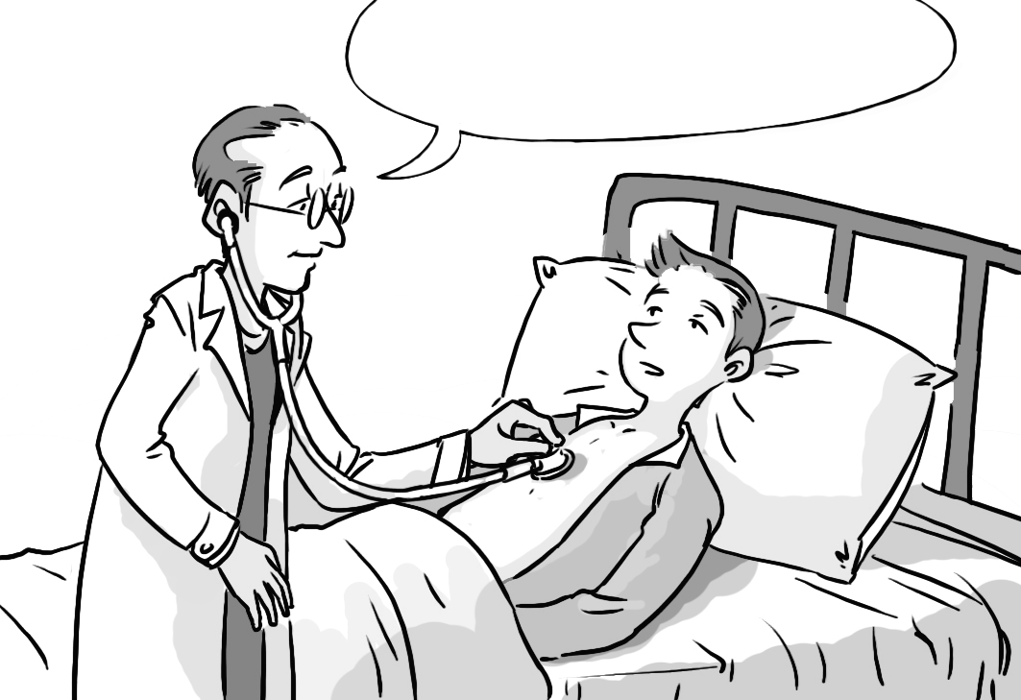

① Help yourself.
② You'll be okay.
③ Open your book.
④ How much is it?
⑤ It's too expensive.
3. 빈칸에 들어갈 말로 알맞은 것은?
A: Does your mother work?
B: Yes, ___________________.
① I am② I'm not③ she does
④ he does⑤ she is
4. 그림의 상황에 어울리는 대화는?
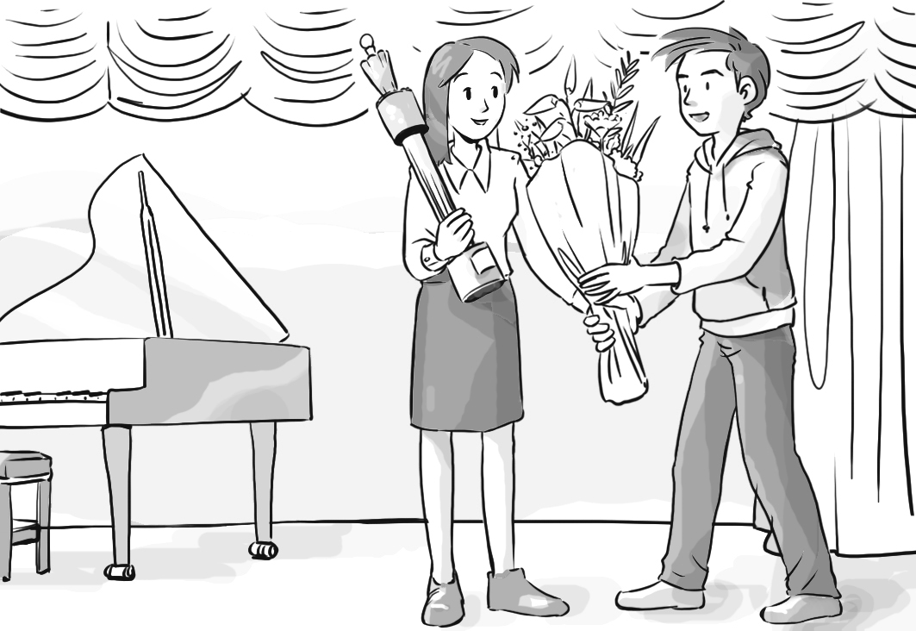
1) A: Congratulations! This is for you.
B: Thank you very much.
2) A: Can I speak to John?
B: Speaking.
3) A: What will you do this Saturday?
B: I will go on a picnic.
4) A: Will you pass me the book?
B: Here you are.
5) A: What's your hobby?
B: My hobby is listening to music.

5. 직업에 대한 설명으로 알맞은 것은?
(A) | 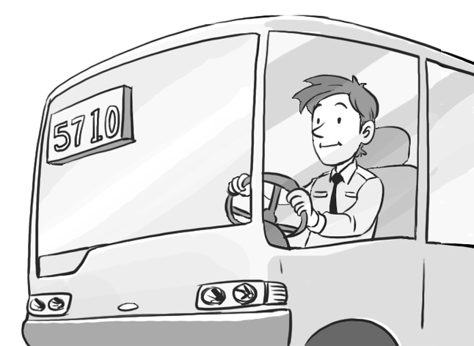 | (B) | 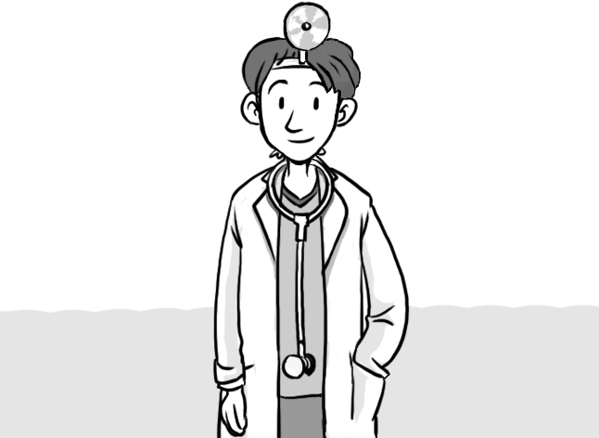 | (C)
(D) | 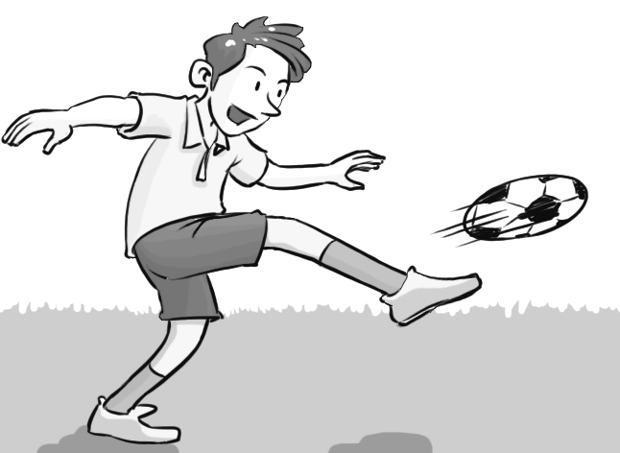 | (E) | 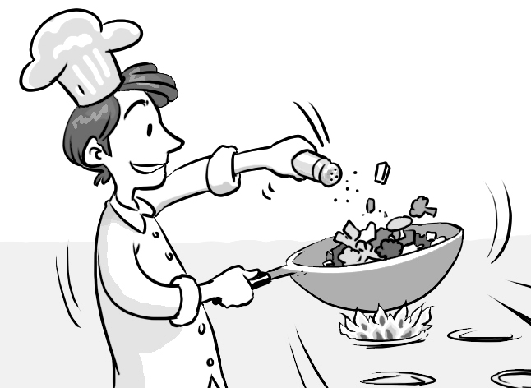
① (A)- He teaches English.
② (B)- He takes pictures.
③ (C)- He plays the piano.
④ (D)- He plays basketball.
⑤ (E)- He cooks in a restaurant.
6. 빈칸에 들어갈 말로 알맞은 것은?
A: I want to make a kite.
Will you help me?
B: _________________
I have to do my homework.
① Sure.
② Okay.
③ Of course.
④ No problem.
⑤ Sorry, I can't.
7. 짝지어진 대화가 어색한 것은?
① A: What does your father do?
B: He is stronger than me.
② A: Where are you from?
B: I'm from Seoul.
③ A: I have a bad cold.
B: Get some rest.
④ A: How was your vacation?
B: It was great.
⑤ A: Are you going back to New York?
B: Yes, I am.
8. 미나가 하려고 하는 일은?
Jiho : Tomorrow is Parents' Day.
Mina: What do you want to do for Mom?
Jiho : I want to clean the house.
How about you?
Mina: I want to do the dishes.

① | 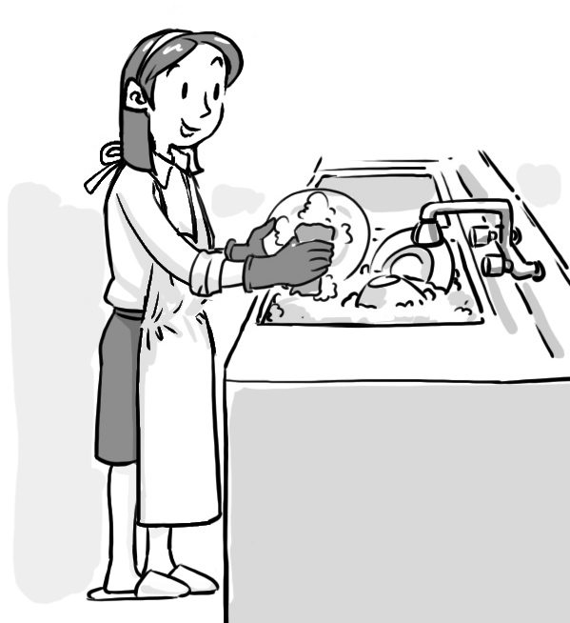 | ② | 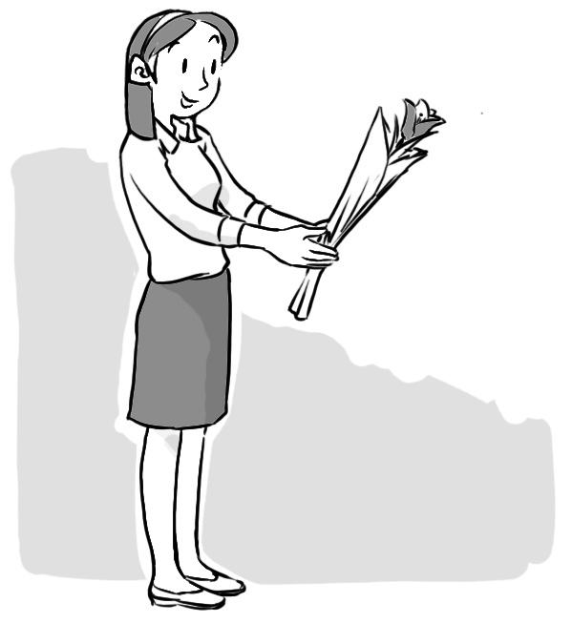 | ③ | 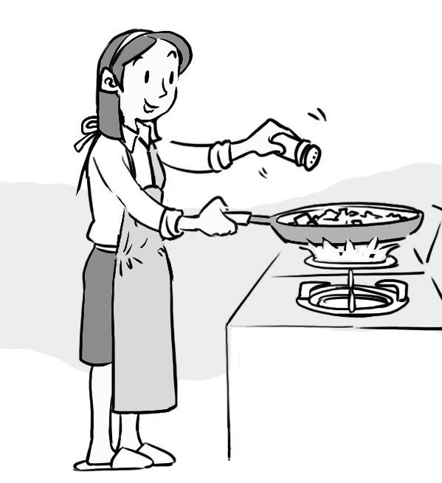
④ | 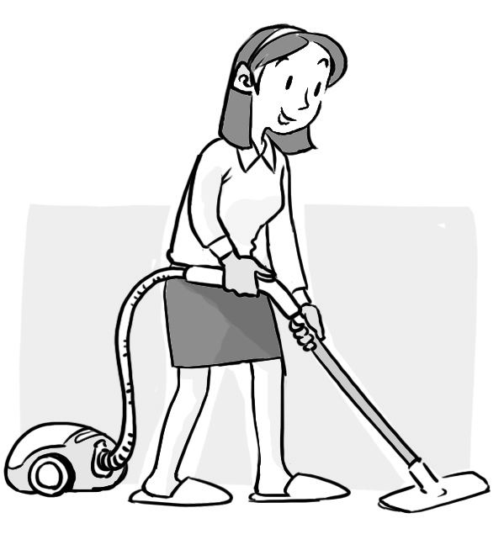 | ⑤ | 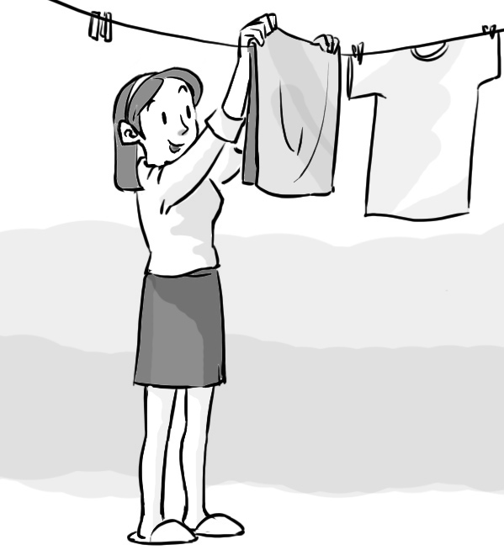
9. 표지판이 나타내는 것은?
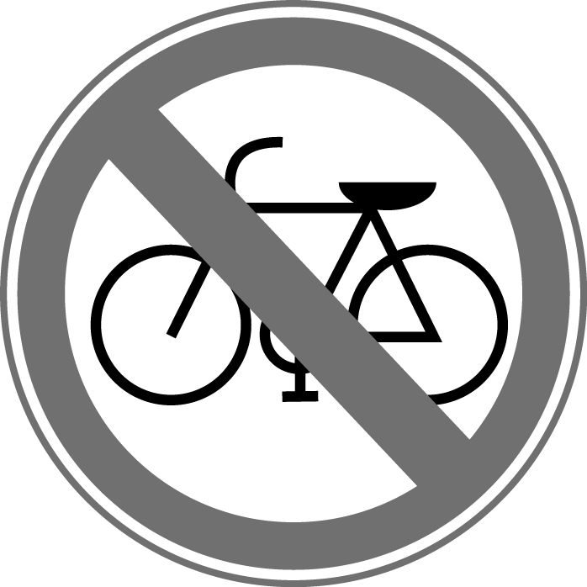 | ① Stop.  ② No bike.  ③ Turn left.  ④ Turn right.  ⑤ No swimming.
10. 지도와 일치하는 설명은?
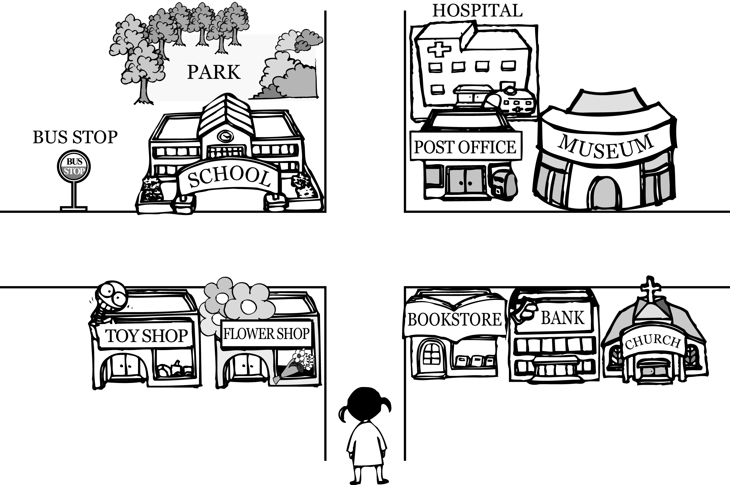
① The hospital is in the park.
② The toy shop is at the corner.
③ The bus stop is near the school.
④ The school is behind the post office.
⑤ The bookstore is between the bank and the church.
11. 초대장을 읽고, 알 수 없는 내용은?
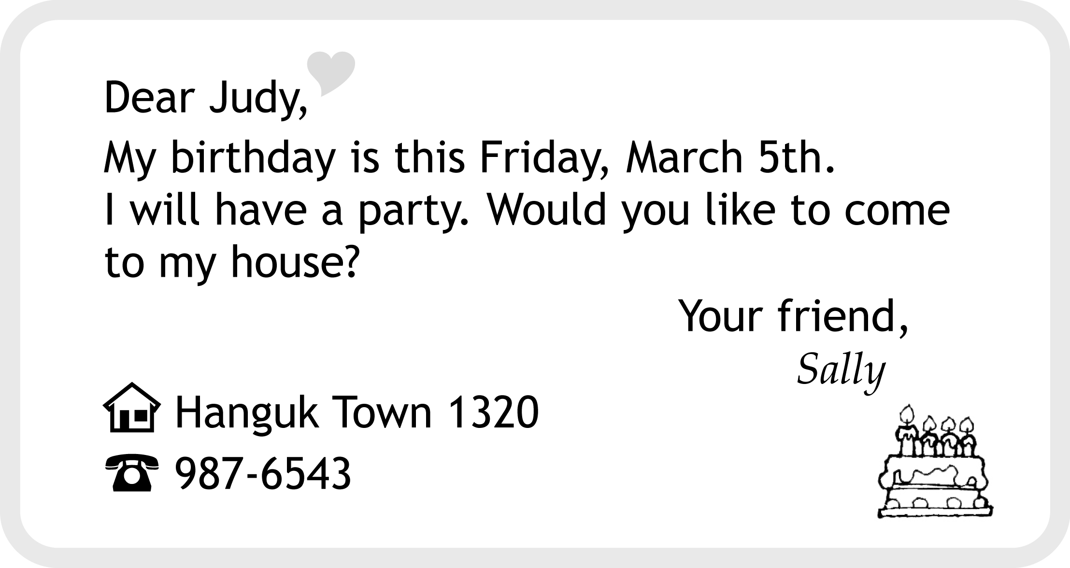
- 날짜② 장소③ 연락처④ 요일⑤ 시각
12. 글의 내용으로 보아 빈칸에 알맞은 낱말은?
I like very much. I like hot weather. I have a long vacation. I can swim in the sea. I can go camping with my family.
① spring ② summer③ fall
④ winter⑤ season
13. 순서에 따라 빈칸에 들어갈 달(month)로 알맞은 것은?
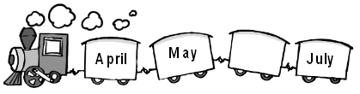
① January ② February③ June
④ August⑤ September
14. 그림으로 보아 Ann과 Kevin이 할 말로 알맞게 짝지은 것은?
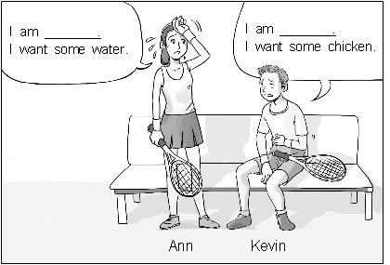
Ann Kevin
① cold hot
② good bad
③ nice kind
④ old young
⑤ thirsty hungry
15. 빈칸에 들어갈 말로 알맞지 않은 것은?
A: Good-bye.
B: ________________________
① Bye.② Take care.③ So long.
④ Excuse me.⑤ See you again.
16. 일기의 밑줄 친 부분 중 잘못 쓰인 것은?
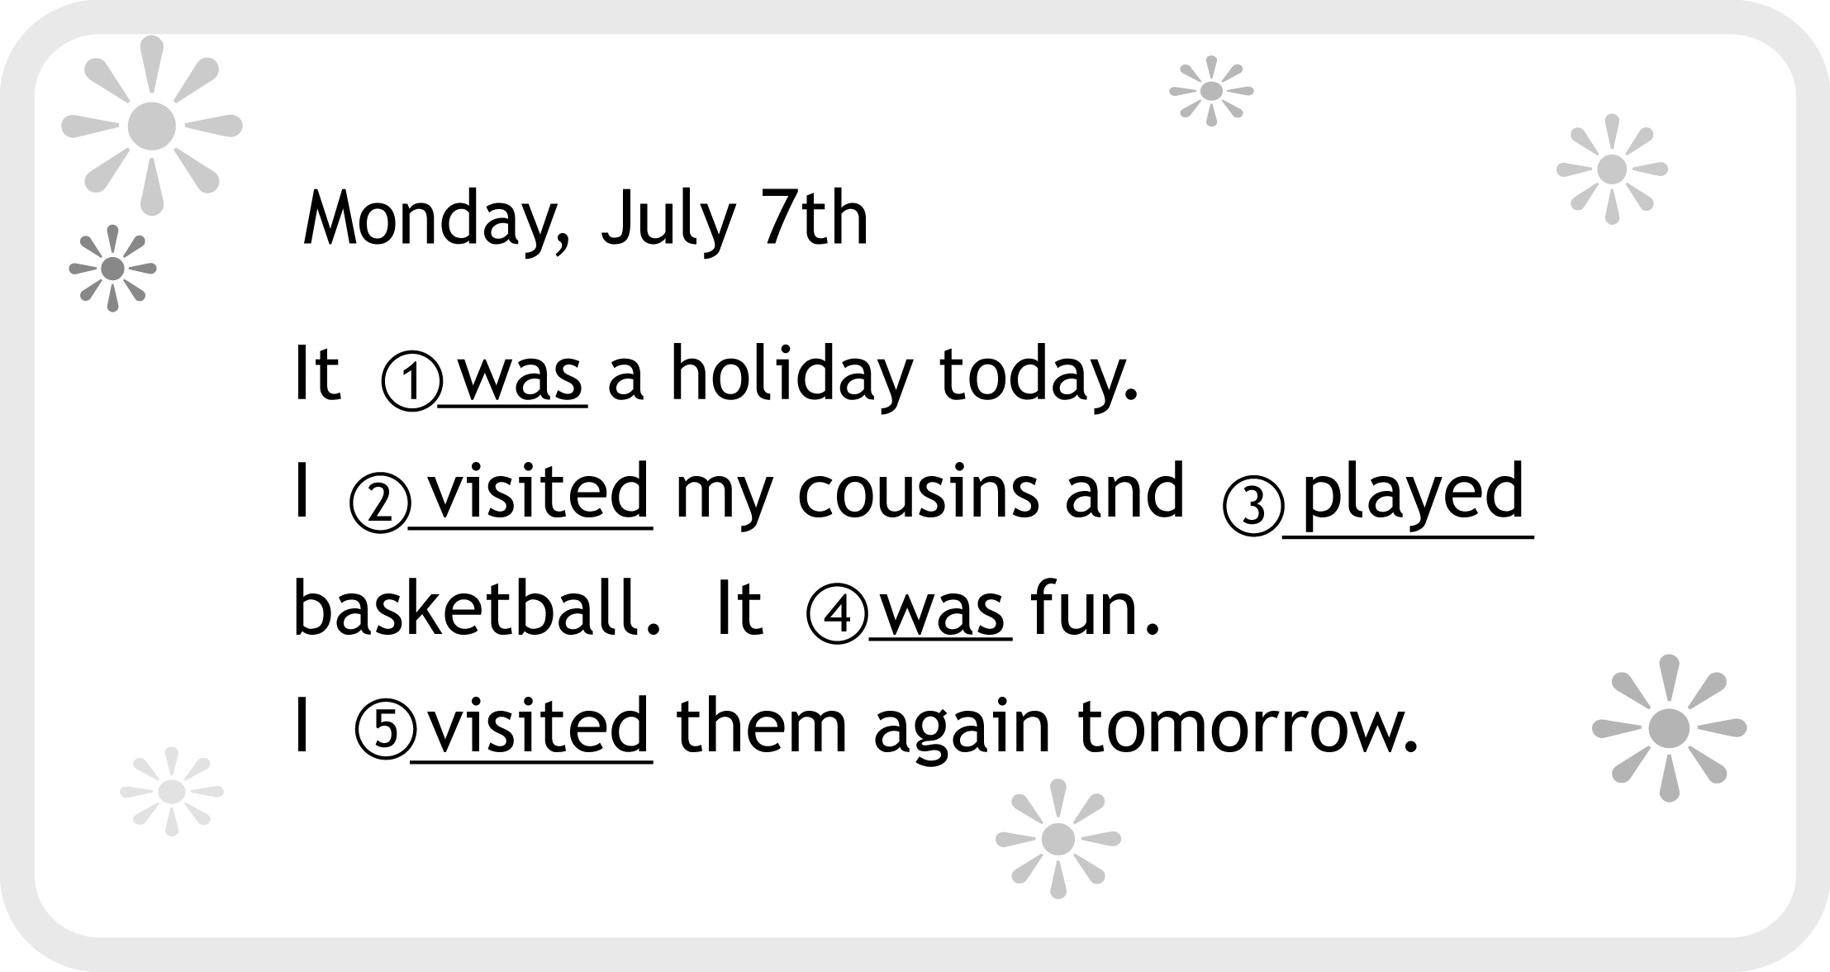
17. 퍼즐의 빈칸에 들어갈 낱말을 나타내는 그림은?
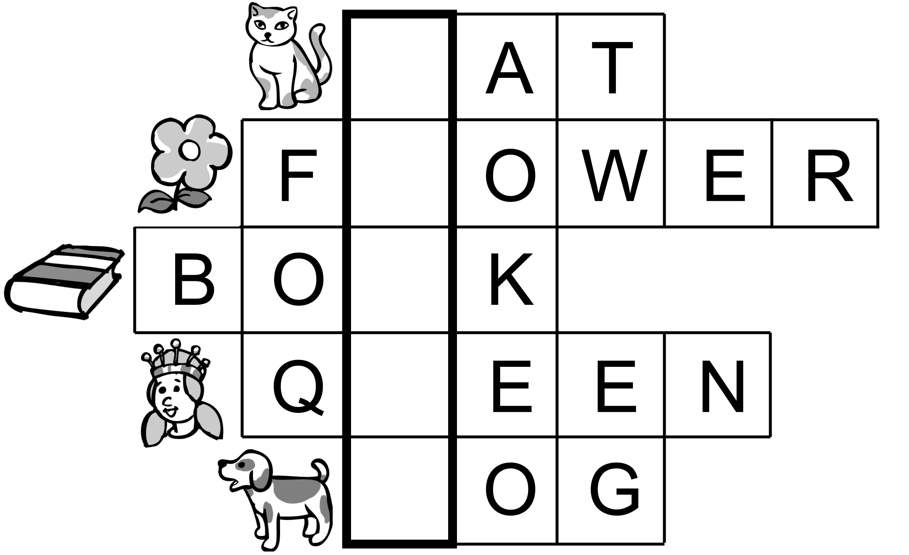
① |  |  |  | ② | 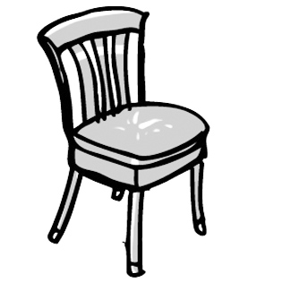 |  | ③
④ | 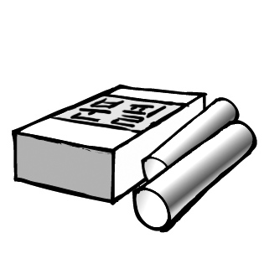 |  |  | ⑤ | 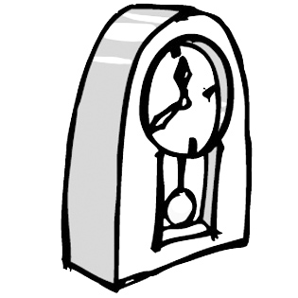
18. 다음 단어 중 나머지 넷을 포함할 수 있는 것은?
① fall② winter③ spring④ season⑤ summer
19. 밑줄 친 부분과 같이 말한 목적은?
A: This Thursday is my birthday.
B: Your birthday?
A: Yes. Would you like to come to my house?
B: Yes, I'd love to.

- 초대하려고 2) 사과하려고 3) 변명하려고 4) 칭찬하려고 5) 충고하려고

20. 대화의 빈칸에 공통적으로 들어갈 말은?
A: Welcome!
B: Thank you for inviting me.
A: You can your coat.
B: Thank you.
A: Oh, don't your shoes.
We wear our shoes in the house.
B: Oh, I see.
① look at② come on③ take care
④ wake up⑤ take off

