중 1 듣기 평가

Html File No 2

1. 다음을 듣고, 미진이의 주간 계획표에서 오늘이 무슨 요일인지 고르시오. (2번)

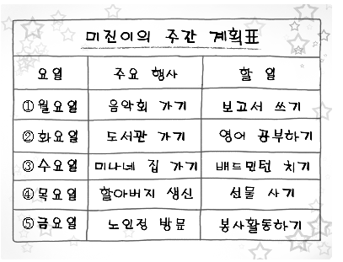

G: I will have a test on Saturday. Today I will go to the library with Sumi. We will study English together.

2. 대화를 듣고, 두 사람이 집으로 출발할 시각을 고르시오. (4번)

|  |  |  |  |  |  |
| --- | --- | --- | --- | --- | --- |
| ① | EMB00000ba8bb4a | ② | EMB00000ba8bb4b | ③ | EMB00000ba8bb4c |
| ④ | EMB00000ba8bb4d | ⑤ | EMB00000ba8bb4e |  |  |

G: I like skating. It's so fun.

B: Nami, it's time to go back home.

G: What time is it?

B: It's 4 o'clock.

G: I want to skate more. Let's go home after 30 minutes.

B: OK.

3. 각 대화를 듣고, 짝지어진 대화가 자연스럽지 않은 것을 고르시오. (1번)

① ② ③ ④ ⑤

① W: Do you like winter?

M: Because it's nice and warm.

② W: What day is it today?

M: It's Monday.

③ W: How was your vacation?

M: It was great.

④ W: May I help you?

M: Yes, please.

⑤ W: Can I have some pizza?

M: Sure. Here you are.

**2010년 12월 전국 연합학력평가**

4. 다음을 듣고, 어떤 과일에 대한 설명인지 고르세요. (5번)

|  |  |  |  |  |
| --- | --- | --- | --- | --- |
| ① | EMB00000cbc0034 |  | ② | EMB00000cbc0035 |
| ③ | EMB00000cbc0037 |  | ④ | EMB00000cbc0036 |
| ⑤ | EMB00000cbc0039 |  |  |  |

W: This fruit is big and round. It’s green and hard outside. It’s red and very juicy inside. It has black seeds. We cut it into pieces before eating it.

5. 대화를 듣고, 두 사람의 관계로 가장 적절한 것을 고르세요. (1번)

① 친구 - 친구

② 의사 - 환자

③ 손님 - 점원

④ 교사 - 학생

⑤ 코치 - 선수

W: Bob! Why don’t we go to see a movie tonight?

M: Sorry, I can’t. I didn’t finish the science homework. How about you?

W: Not yet, but we still have two more days. Let’s do it together tomorrow!

M: Okay, then let’s go.

6. 대화를 듣고, 여자가 지불해야 할 금액을 고르세요. (5번)

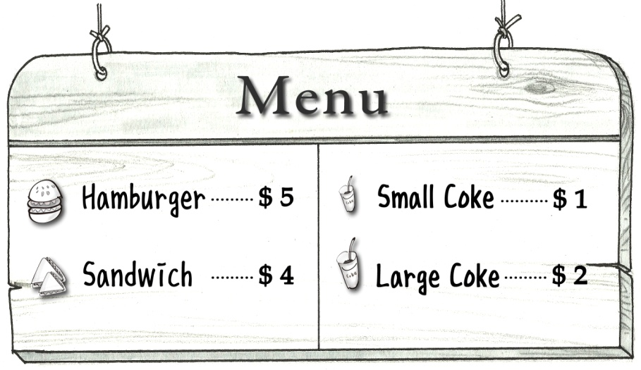

M: Can I take your order?

W: Yes, please. I’d like two hamburgers.

M: Anything to drink?

W: One large coke, please.

M: Two hamburgers and one large coke. Here you are.

W: Thank you.

7. 대화를 듣고, 남자의 기분으로 가장 적절한 것을 고르세요. (2번)

① 무섭다

② 속상하다

③ 행복하다

④ 지루하다

⑤ 만족스럽다

M: Today is my birthday.

W: Happy birthday, David. You look so sad. What’s wrong?

M: My family doesn’t know it’s my birthday today. Nobody gave me any presents. My parents didn’t have a birthday party for me.

W: I’m sorry to hear that.

8. 대화를 듣고, 체육대회가 열리는 날짜를 고르세요. (4번)

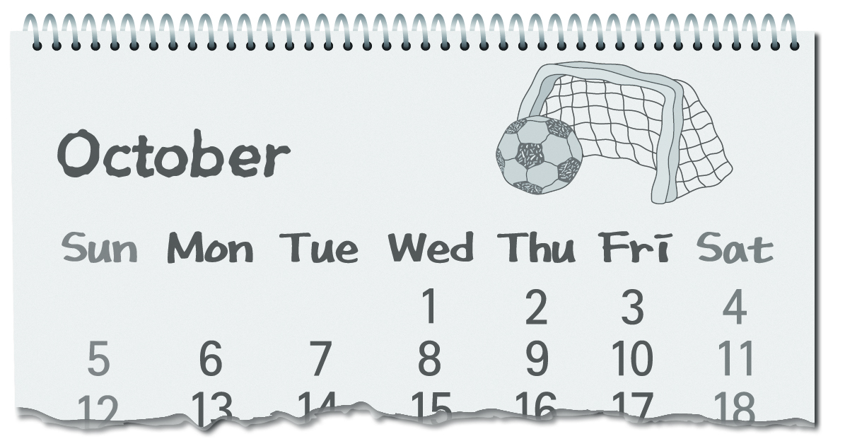

① 10월 2일

② 10월 3일

③ 10월 6일

④ 10월 7일

⑤ 10월 9일

M: I can’t wait for the sports day next week.

W: Same here. What’s the date today?

M: It’s October 2nd. We have five days to go.

W: I’m so excited.

M: Me, too. This is my first sports day in middle school.

W: I’m sure we’ll have a lot of fun next Tuesday.

9. 대화를 듣고, 남자의 말에 이어질 여자의 응답으로 가장 적절한 것을 고르세요. (3번)

① Good job.

② Cheer up.

③ No problem.

④ That’s right.

⑤ You’re welcome.

W: Good afternoon. May I help you?

M: Yes, please. I’m looking for a T-shirt.

W: How about this one? It’s a new style.

M: It looks nice, but I don’t like this color. Will you show me another T-shirt?

W: No problem.

10. 대화를 듣고, 두 사람의 관계로 가장 적절한 것을 고르시오. (5번)

① 의사－ 환자 ② 택시 기사－승객 ③ 감독－ 운동 선수 ④ 사진 작가－모델

⑤ 옷가게 점원－ 손님

W: How can I help you?

M: I’m looking for a T-shirt.

W: How about this one? Would you like to try it on?

M: It looks nice. But do you have it in white?

W: Sure. What size would you like?

M: Large, please.

11. 대화를 듣고, 여자가 가려고 하는 장소를 고르시오. (2번)



W: Excuse me. How can I get to the post office?

M: Let me see. Go straight to Main Street.

W: Go straight?

M: Yes. And then turn right. It’s on your left.

W: Oh, I see.

M: It’s next to the hospital. You can’t miss it.

W: Thank you.

12. 대화를 듣고, 남자가 여자에게 부탁한 일로 가장 적절한 것을 고르시오. (1번)

① 일찍 깨워주기 ② 숙제 도와주기 ③ 방 청소 해주기

④ 학교 데려다주기 ⑤ 도시락 챙겨주기

W: David, it’s time to go to bed. It’s already eleven o’clock.

M: Mom, I have to finish my homework.

W: It’s late. You can do it early tomorrow morning.

M: Hmm.... Then, can you wake me up at six o’clock in the morning?

W: Sure, don’t worry.

13. 대화를 듣고, 여자가 남자에게 제안한 것으로 가장 적절한 것을 고르시오. (3번)

① 도서관 가기 ② 과학 실험하기 ③ 인터넷 활용하기

④ 안내소 방문하기 ⑤ 친구에게 물어보기

W: Chris, where are you going?

M: I’m going to Tom’s house to do the science homework. Did your group finish it?

W: Yes, we did. Why is your group still working on it?

M: Well, we can’t find any useful book.

W: How about using the Internet?

M: That’s a good idea. Thanks.

14. 다음을 듣고, 두 사람의 대화가 어색한 것을 고르시오. (2번)

① ② ③ ④ ⑤

W: Number one

M: Will you help me?

W: Sure. What is it?

W: Number two

M: Where is the bus stop?

W: I go to school by bus.

W: Number three

M: What are you doing now?

W: I’m listening to music.

W: Number four

M: May I use your phone?

W: Sure. Here you are.

W: Number five

M: Is there a cat in the box?

W: Yes, there is.

15. 대화를 듣고, 남자의 직업으로 가장 적절한 것을 고르시오. (4번)

① 스포츠 기자 ② 소방관 ③ 미용사

④ 운동 코치 ⑤ 사진 작가

M: You did a great job today!

W: Thanks, Coach. I’m really happy we won the game.

M: Your goal saved our team. It was amazing!

W: Your training was really helpful.

M: I’m glad to hear that.

16.대화를 듣고, 남자의 마지막 말에 이어질 여자의 응답으로 가장 적절한 것을 고르시오. (3번)

① Me, too. ② Here it is.

③ Sure, I will. ④ That’s too bad.

⑤ Well done, please.

M: Can you play the piano?

W: Yes, I’m pretty good at it. How about you?

M: I don’t know how to play. Will you teach me?

W: Sure, I will.

17. 대화를 듣고, 남자의 마지막 말에 이어질 여자의 응답으로 가장 적절한 것을 고르시오. (3번)

① Ten dollars. ② So delicious.

③ On the table. ④ With a spoon.

⑤ Five minutes later.

M: Mom, I’m home. I’m so hungry.

W: Oh, good! I made some sandwiches for you.

M: Great! Where are they?

W: On the table.

**2011년 제1회 전국 중학교 영어듣기능력평가 문제 만들기**

18. 다음을 듣고, 무엇에 관한 설명인지 고르세요. (1번)

1. 비행기
2. 배
3. 자동차
4. 기차
5. 새

M: This is something that you ride in. It has wings and can move through the sky. People usually take this when they visit other countries.

19. 대화를 듣고, 해가 뜨는 시각을 고르세요. (2번)

1. 5:00
2. 5:10
3. 5:20
4. 5:30
5. 5:40

W: When can we see the sunrise?

M: We have to wait 20 more minutes to see it.

W: What time is it now?

M: It's 5:30 a.m.

20. 다음을 듣고, 오늘 오후의 날씨를 고르세요. (3번)

|  |  |
| --- | --- |
| ① | ② |
| EMB000007f02cd7 | EMB000007f02cd8 |
|  |  |
| ③ | ④ |
| EMB000007f02cdb | EMB000007f02cdc |
|  |  |
| ⑤ |  |
| EMB000007f02cde |  |

W: Good morning. This is Amy Johnson with the Weather. Today, it will be sunny in the morning, but in the afternoon you'll see lots of clouds in the sky. Tomorrow, it will rain and you will need to take an umbrella.