2007년 국가수준 학업성취도 평가 영어(A형)
초6-2007
E6-3

- 다음 대화를 듣고, 피터가 하고 싶어 하는 것을 고르시오. (3번)

(1) | (2) | (3) | (4)
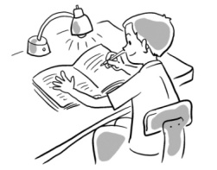 | 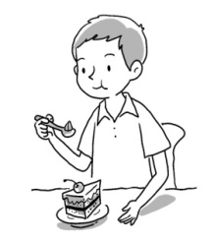 | 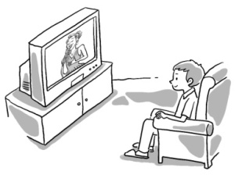 | 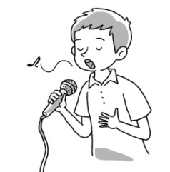

W: Peter, come and have some cake.
B:Can I watch TV first? My favorite singer is on TV now.
W: No, Peter. Have some cake and do your homework.
B: Not right now, please!
W: Peter!
B: Okay.

2. 다음 대화를 듣고, 무엇에 관하여 이야기하고 있는지를 고르시오. (4번)
① 생일 잔치 ② 봉사 활동 ③ 학교 운동회 ④ 친척 방문

B: I visited my aunt in Gyeong-Ju last week.
G: What did you do there?
B: I went to Bulguksa.
G: Oh, you had a good time there.

- 다음 대화를 듣고, 영호가 지난 주말에 한 일을 고르시오. (1번)

(1) | (2) | (3) | (4)
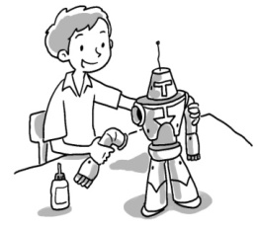 | 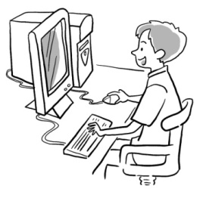 | 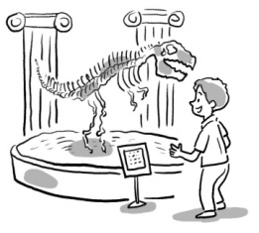 | 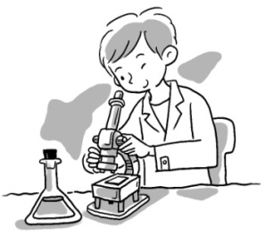

B: What did you do last Saturday?
G: I went to the Science Museum. What did you do, Youngho?
B: I made a toy robot at home.
G: Sounds like fun!

4. 다음 대화를 듣고, 남자 아이의 응답으로 가장 알맞은 것을 고르시오. (2번)
① But we have Chuseok.
② But we have a long vacation.
③ But it's hot.
④ But it's nice and warm.
G: Do you like spring?
B: No. I like winter.
G: Winter? It's too cold.
B: But we have a long vacation.

5. 다음 대화를 듣고, 여자 아이가 찾고 있는 물건이 어디에 있는지 고르시오. (4번)

(1) | (2) | (3) | (4)
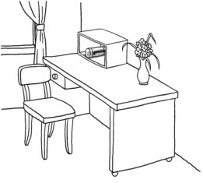 | 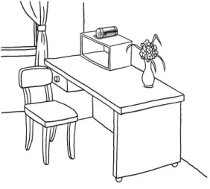 | 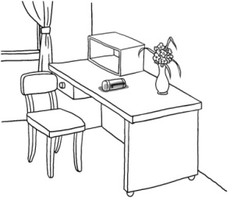 | 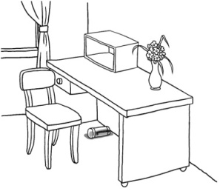

G: Dad, where's my pencil case?
M: It's in the bookcase.
G: No, it's not in the bookcase.
M: Uhhh, here! It's under the desk.

6. 다음 대화를 듣고, 여자 아이의 응답으로 알맞지 않은 것을 고르시오. (2번)
① I'm sick.
② I feel good.
③ I have a headache.
④ I have a bad cold.

B: Let's play baseball this afternoon.
G: Sorry, I can't.
B: What's wrong?

7. 다음 대화를 듣고, 제인의 기분이 좋은 이유를 나타내는 그림을 고르시오. (1번)

(1) | (2) | (3) | (4)
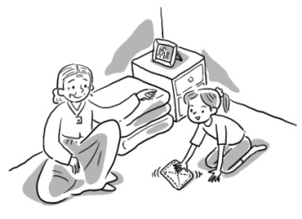 | 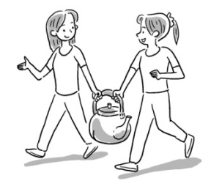 | 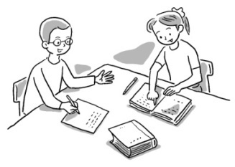 | 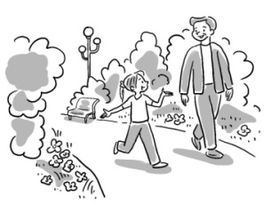

B: You look happy today, Jane.
G: I am happy.
B: Why?
G: I went to a nursing home with my mom this morning. I helped some old people there.
B: That was nice.

8. 다음을 듣고, 수아의 선생님이 누구인지 고르시오. (3번)

(1) | (2) | (3) | (4)
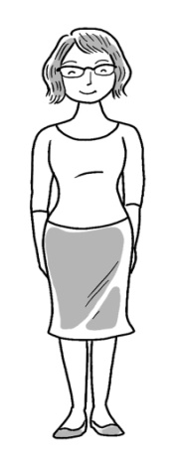 | 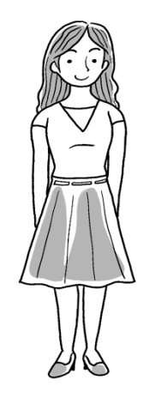 | 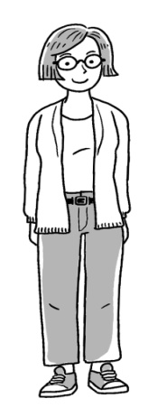 | 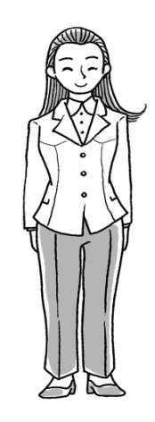

G: Hello, I'm Sua. I want to tell you about my teacher. She has short hair. She is wearing pants and she is wearing glasses.

9. 다음 대화를 듣고, 인호가 여름 방학에 할 일이 아닌 것을 고르시오. (2번)

(1) | (2) | (3) | (4)
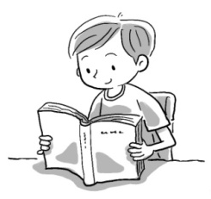 | 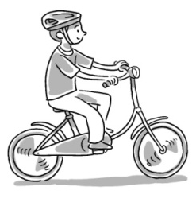 | 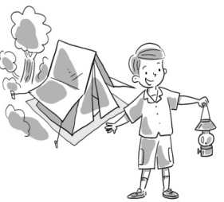 | 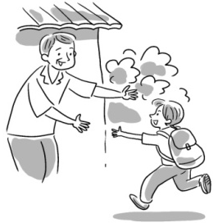

B: What will you do this summer vacation, Mina?
G: I'll visit my grandparents in Daegu.
B: Good!
G: How about you, Inho?
B: I'll read books, go camping, and visit my uncle in Incheon.
G: Sounds like fun!

10. 다음 중 대화가 가장 자연스러운 것을 고르시오. (1번)
① ② ③ ④
① G: Excuse me. Is this the Hankuk building?
B: Sorry, I don't know.

② G: This box is too heavy. Help me, Please!
B: Sounds good.

③ G: I want to dance well. Will you teach me?
B: Good job!

④ G: Can you help me with my homework?
B: Watch out!

11. 다음 대화를 듣고, 제니가 하고 싶은 일을 고르시오. (2번)

(1) | (2) | (3) | (4)

G: Let's talk about our show. What do you want to do, Chris?
B: Let's play the piano. How about you, Jenny?
G: I can't play well. I want to dance. Let's dance together.

12. 다음 대화를 듣고, 남자 아이의 응답으로 가장 알맞은 것을 고르시오. (1번)
① Sounds good. ② That's all right. ③ I'm sorry. ④ You're welcome.

B: What did you do on Sunday?
G: I went to the Children's Park.
B: What did you see there?
G: Lots of flowers and trees.

13. 다음 대화를 듣고, 여자 아이의 응답으로 가장 알맞은 것을 고르시오. (4번)
① I study English. ② I'm listening to music.
③ I will have a birthday party. ④ I went to an English camp.

B: How was your vacation?
G: I had a great time.
B: What did you do?

14. 다음을 듣고, 두 사람의 대화가 자연스럽지 못한 것을 고르시오. (1번)
① ② ③ ④

① B: How was your vacation?
G: It is mine.

② B: Will you help me with my homework?
G: No problem.

③ B: What did you do yesterday?
G: I stayed at home.

④ B: Tomorrow is my birthday.
G: Happy Birthday!

15. 다음 대화를 듣고, 남자의 응답으로 가장 알맞은 것을 고르시오. (3번)
① He has an earache. ② He went to the hospital.
③ That's too bad. ④ That's not fun.

M: Hello, Mr. Park speaking.
W: Hi, Mr. Park. This is Jinho's mom. Mr. Park, Jinho can't come to school today.
M: Why?
W: He's sick. He has a bad cold.
M: That's too bad.

16.다음 대화를 듣고, 대화가 이루어지는 장소를 고르시오. (3)

(1) | (2) | (3) | (4)
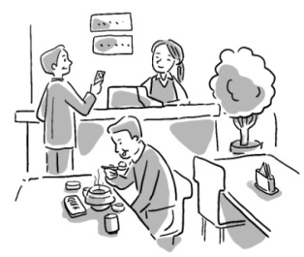 | 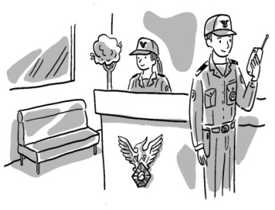 | 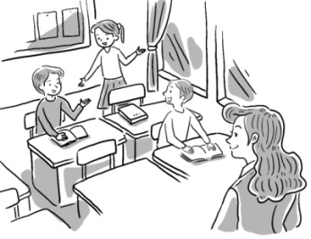 | 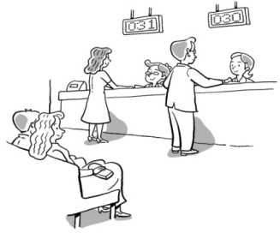

W: Hi, everyone.
G & B: Hello, Ms. Kim.
W: Today we have a new student. This is Tony.
B: Hi, I'm Tony. Nice to meet you.
G & B: Nice to meet you, too.

17.다음 대화를 듣고, 나미와 폴이 가려는 장소와 시각을 쓰시오. (도서관, two)

- 도서관 / 2시
- 공원 / 2시
- 도서관 / 12시
- 공원 / 12시

B: Hello.
G: Hello, this is Nami. Is Paul there?
B: Speaking.
G: Hi, Paul. Are you free now?
B: Yes, I'm just resting.
G: Good! Let's go to the library. Can we meet at two?
B: Okay. See you then.

18.다음 대화를 듣고, 남자 아이가 찾아가려는 장소를 고르시오. (병원)
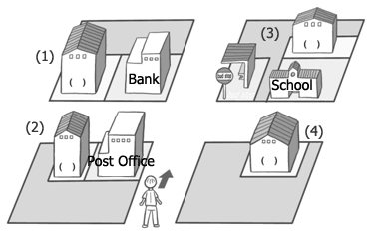
- (2) (3) (4)

B: Excuse me, where is the hospital?
G: Go straight and turn right at the corner. It's behind the school.
B: Behind the school?
G: Yes, it's near the bus stop.

19.다음 대화를 듣고, 메리가 어느 나라에서 왔고, 몇 층에 사는지를 고르시오. (1)

- 영국 / 2층
- 영국 / 7층
- 미국 / 2층
- 미국 / 7층

B: Where are you from, Mary?
G: I'm from England.
B: England? Oh, I see. Where's your room?
G: It's on the second floor.

20.다음 대화를 듣고, 빈칸에 들어갈 낱말을 고르시오. (play/ doctor) 1

A: Let's (1)________ computer games this afternoon.
B: Sorry, I can't. I must see a (2) .

- Play – doctor
- Pray – teacher
- Play – teacher
- Pray – doctor

B: Let's play computer games this afternoon.
G: Sorry, I can't. I must see a doctor.

