**2006년 국가수준 학업성취도 평가 영어(A형)**

**초6-2006**

**E6_2**

1. 다음 대화를 듣고, 진호가 하고 싶은 것을 고르시오. (2번)

|  |  |
| --- | --- |
| (1) | (2) |
| EMB0000070c282f | EMB0000070c282f |
| (3) | (4) |
| EMB0000070c282f | EMB0000070c282f |

B: We don't have class this Saturday. What do you want to do, Mina?

G: I want to go to Namdaemun with my family. How about you, Jinho?

B: I want to go to the school library and read books.

G: Sounds good. I saw so many new books there.

1. 다음 대화를 듣고, 진호가 사려는 물건을 고르시오. (4번)

|  |  |
| --- | --- |
| (1) | (2) |
| EMB0000070c2839 | EMB0000070c2839 |
| (3) | (4) |
| EMB0000070c2839 | EMB0000070c2839 |

G: Hi, Jinho.

B: Hi, Mina.

G: What are you doing here? Do you want to buy something?

B: Yeah. Tomorrow is my brother's birthday.

G: Oh, I see. Um... look at this soccer ball. It looks great.

B: Yes, it does. My brother likes playing soccer. I'll take it.

1. 다음 비교하는 말을 듣고, 그림의 내용과 일치하는 것을 고르시오. (2번)

|  |  |  |  |
| --- | --- | --- | --- |
| (1) | (2) | (3) | (4) |
| EMB0000070c2830 | EMB0000070c2830 | EMB0000070c2830 | EMB0000070c2830 |
| Inho Tony | Yumi Judy | Inho Tony | Yumi Juday |

1번. Tony is taller than Inho.

2번. Yumi is faster than Judy.

3번. Tony is stronger than Inho.

4번. Yumi is older than Judy.

1. 다음 대화를 듣고, 진호가 오늘 학교에서 공부할 과목이 아닌 것을 고르시오. (3번)

|  |  |  |  |
| --- | --- | --- | --- |
| (1) | (2) | (3) | (4) |
| EMB0000070c2834 | EMB0000070c2834 | EMB0000070c2834 | EMB0000070c2834 |

B: What day is it today, Mom?

W: It's Wednesday.

B: Wednesday? I have English and Math.

W: Jinho, is that all?

B: I have Science and Music, too.

1. 다음 대화를 듣고, 하는 일과 시간이 바르게 짝지어진 것을 고르시오. (4번)

|  |  |  |  |
| --- | --- | --- | --- |
| (1) | (2) | (3) | (4) |
| EMB0000070c2837 | EMB0000070c2837 | EMB0000070c2837 | EMB0000070c2837 |
| 10:00 | 11:00 | 10:00 | 11:00 |

G: What time do you go to bed?

B: I go to bed at 11 o'clock.

G: That's too late.

6. 다음 대화를 듣고, 여자 아이의 응답으로 가장 알맞은 것을 고르시오. (2번)

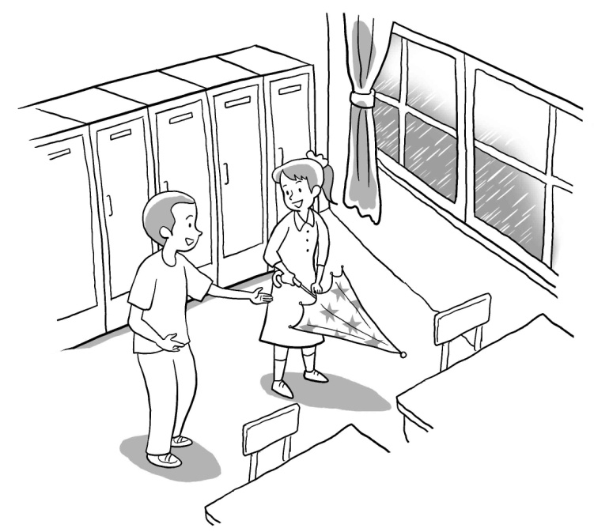

① It's red.

② It's Nami's.

③ It's very old.

④ It's very big.

B: Wow! Look at this yellow umbrella. It's really pretty. Is it yours?

G: No, that's not mine.

B: Then, whose umbrella is it?

G:

1. 다음 대화를 듣고, 내용에 가장 알맞은 그림을 고르시오. (4번)

|  |  |  |  |
| --- | --- | --- | --- |
| (1) | (2) | (3) | (4) |
| EMB0000070c2838 | EMB0000070c2838 | EMB0000070c2838 | EMB0000070c2838 |

B: How are you?

G: I'm OK. How about you?

B: I'm fine, but my mom has a headache.

G: Oh, that's too bad.

8. 다음을 듣고, 두 사람의 대화가 가장 자연스러운 것을 고르시오. (4번)

① ② ③ ④

1번.

B: You did very well.

G: That's too bad.

2번.

B: How are you today?

G: It's sunny.

3번.

B: Oh, I'm very sorry. Are you OK?

G: Sorry, I can't.

4번.

B: Thank you for your help.

G: You're welcome.

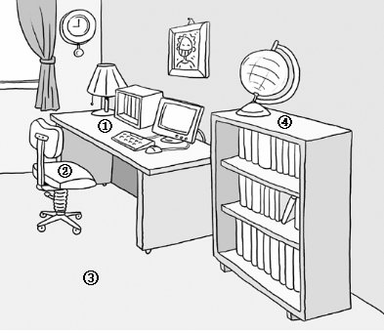9. 다음 대화를 듣고, 지호가 찾고 있는 물건이 어디에 있는지 고르시오. (1번)

W: Jiho, hurry up! It's already nine.

B: Oh, I'm late. Where's my bag?

W: There! It's on the desk.

B: Thank you, Mom.

10. 다음 대화를 듣고, 두 아이가 무엇에 관해서 이야기하고 있는지를 고르시오. (2번)

① TV 프로그램 ② 과학 박물관 ③ 미술 전시회 ④ 새로운 게임

G: Where did you go yesterday?

B: I went to the Science Museum.

G: What did you see there?

B: A future house, robots, a new TV and a new telephone. I had a great time.

G: Sounds great!

11. 다음을 듣고, 이어질 응답으로 알맞은 것을 고르시오. (1번)

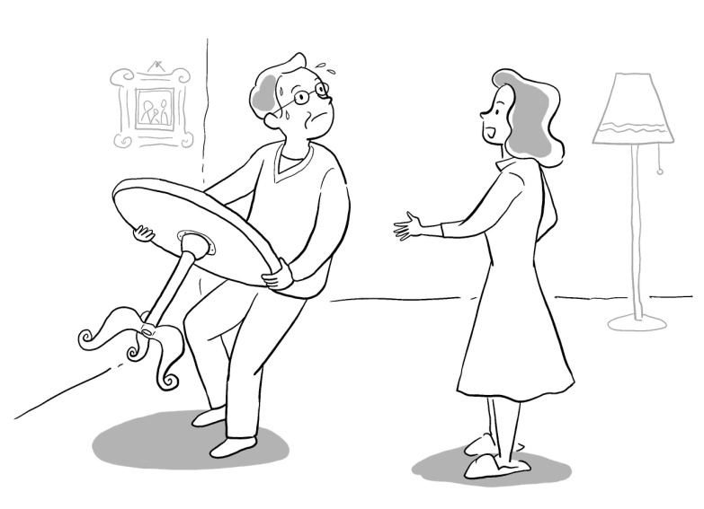

① No problem.

② Thank you.

③ You're welcome.

④ Good job.

M: This table is too heavy. Can you help me, please?

12. 다음 대화를 듣고, 지난 주말에 여자 아이가 한 일을 고르시오. (2번)

|  |  |  |  |
| --- | --- | --- | --- |
| (1) | (2) | (3) | (4) |
| EMB0000070c282e | EMB0000070c282e | EMB0000070c282e | EMB0000070c282d |

B: What did you do last weekend?

G: I went to the park.

B: What did you see there?

G: Lots of birds, trees and flowers. I took some pictures, too.

13. 다음 대화를 듣고, 알맞은 계절 그림을 고르시오. (3번)

|  |  |  |  |
| --- | --- | --- | --- |
| (1) | (2) | (3) | (4) |
| EMB0000070c2833 | EMB0000070c2833 | EMB0000070c2833 | EMB0000070c2833 |

G: What a nice day!

B: Do you like spring?

G: Yes, I do. I like spring. It's nice and warm.

14. 다음을 듣고, 남자 아이의 응답으로 알맞은 것을 고르시오. (2번)

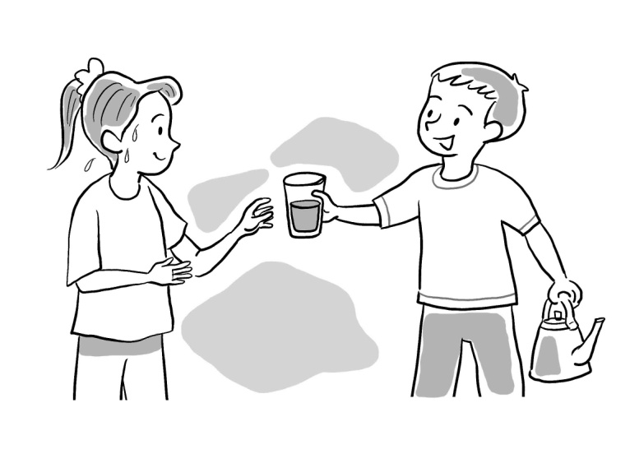

① No, thank you.

② Here you are.

③ You're welcome.

④ I'm sad.

G：I'm thirsty. Can I have some water?

15. 다음 대화를 듣고, 피터의 응답으로 알맞은 것을 고르시오. (1번)

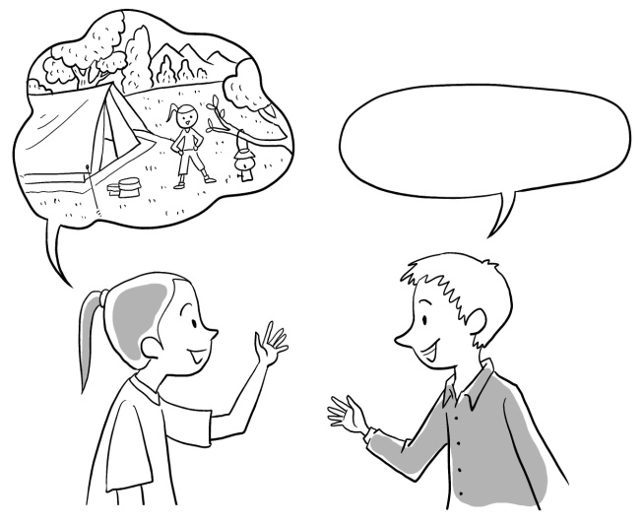

① I'm going to visit my uncle.

② Go straight.

③ See you later.

④ That's too bad.

B: Nami, what are you going to do this summer?

G: I'm going to go camping. What about you, Peter?

16. 다음 대화를 듣고, 알맞은 계절과 날씨를 고르시오. (여름/ 비가 오는 날씨)

1. 봄 / 맑은 날씨
2. 여름 / 비오는 날씨
3. 가을 / 뜨거운 날씨
4. 겨울 / 눈오는 날씨

B: Mom, I'm home.

W: How's the weather outside?

B: It's raining.

W: We have lots of rain in the summer.

B: Right.

17. 다음 대화를 듣고, 여자 아이의 생일을 고르시오. (5월 5일)

1. 5월 1일
2. 5월 5일
3. 8월 1일
4. 8월 20일

G: It's May 1. My birthday is in May.

B: When in May?

G: It's May 5th.

B: You're so lucky. That's Children's Day!

G: When is yours, Jinho?

B: It's August 20th.

18. 다음 대화를 듣고, 남자 아이가 찾아가려는 장소를 고르시오. (2)

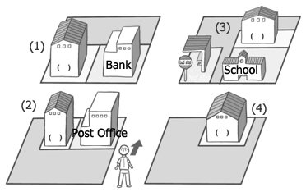

B: Where is the bookstore?

G: Go straight and turn left. It's by the post office.

19. 다음 대화를 듣고, 두 사람이 가려는 장소와 남수가 걸어가지 못하는 이유를 우리말로 쓰시오. (공원)

1. 공원
2. 극장
3. 학교
4. 집

G: Let's go to the park, Namsu.

B: Sounds good. How can we get there?

G: We can walk there.

B: No. I don't want to walk. I'm tired. Let's go by bus.

20. 다음을 듣고, 가족의 직업에 맞는 낱말을 영어로 완성하시오. (4)

|  |  |  |  |
| --- | --- | --- | --- |
| (1) | Father - teacher | Mother - nurse | Sister – police officer |
| (2) | Father – police office | Mother - teacher | Sister – nurse |
| (3) | Father - nurse | Mother - nurse | Sister – teacher |
| (4) | Father - teacher | Mother – police office | Sister – nurse |

B: My father is a teacher. My mother is a police officer. My sister is a nurse.